Learning to Learn Curriculum
Overview
The Learning to Learn (L2L) curriculum at Nancealverne School is followed by pupils where a process based, sensory and developmental curriculum is appropriate to meet their learning needs.
These pupils access educational experiences through a Learning to Learn rolling pathway, within which engaging topics are changed half termly. Within this the National Curriculum us used as a ‘vehicle’ for learning securing equality of opportunity in subjects studied / accessed. Within these topics we provide a wide variety of multi-sensory activities, learning invitations and opportunities to consolidate existing skills and to learn new ones.
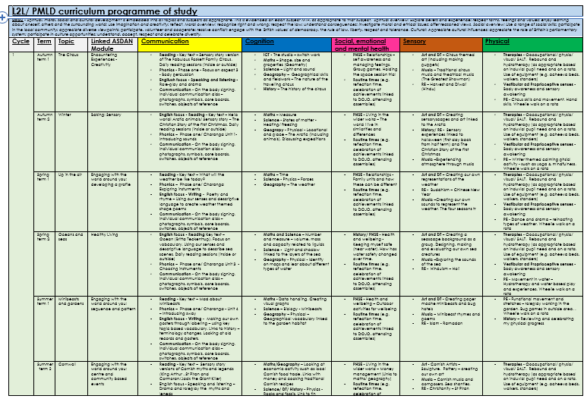
These learning experiences may be provided in a variety of formats – individual, paired, small group and whole group. However we recognise the individual needs, personalised learning plans and talents of each learner which facilitates development of their intellectual, moral, physical, social, spiritual and creative capacities. Therefore, each pupil has a personalised learning to learn profile, which includes objectives and targets set taking information from variety of sources including:
- Developmental stage of the learner/ Engagement model of learning
- EHC Plans
- Reports and information from multi-agency teams and involved professionals (including therapy plans and advice/guidance)
- Information gained from parents/carers
- Levels of support/resources required to access/engage in purposeful learning
The above is offered by a highly skilled and specialist team of teachers and teaching assistants, working seamlessly with external agencies and multi-professional teams to ensure the best outcomes for our pupils.

Learning areas
Following the recommendations of the Rochford Review, we have adopted the five areas of engagement as a means of showing progress. Through these areas pupils will develop interests, practice and refine skills and learn generalise the skills they have learned in different ways and in different situations. They will learn how their actions affect their world and the people in it. This is incorporated into our learning to learn programme of study learning, which is focused around the EHCP areas of need:
- Communication
- Cognition and learning
- Social, emotional and mental health
- Sensory
- Physical
There are many methods for our curriculum delivery. Here are just a few examples of some of our favourite ways to learn, linked to the EHCP areas of need as above.

Communication and Interaction
Includes:
- receptive communication
- expressive communication
Pupils are supported to develop skills that underpin communication, such as shared attention, responding consistently, turn taking, anticipating, showing preferences and making choices. We communicate in lots of different ways; objects of reference, vocalisations, facial expression, body language, photographs, objects of reference, core boards.

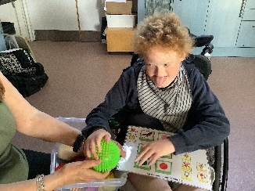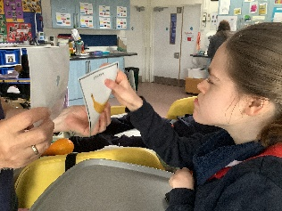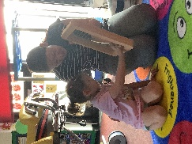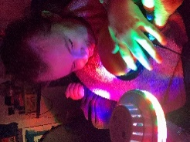

expressing more using core boards using photo cards recognising myself communicating I want more

Cognition and Learning

Includes:
- Exploration
- Realisation
- Anticipation
- Persistence
- Initiation

Pupils are supported to develop their understanding of the world around them and their ability to influence, impact and explore this. They are supported to develop the above skills through a variety of purposely selected activities. Pupils are encourage to explore and participate co=actively or independently in activities wherever possible.

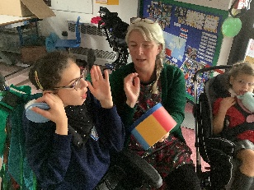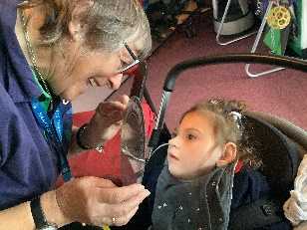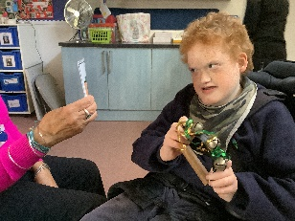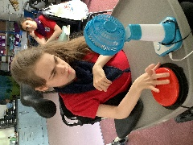

Co-active exploration understaidng my routine following prompts and symbols using swithces independently

Social Emotional and Mental Health Development (SEMH)

Includes:
- Social Affection
- Emotional Affection
Pupils are supported to develop the skills required to be able to get their needs met, co-operate with others and share understanding in their environment. They are also supported to develop the ability to use the skills required in order to recognise their own feelings, control some behaviours and demonstrate their own emotions.
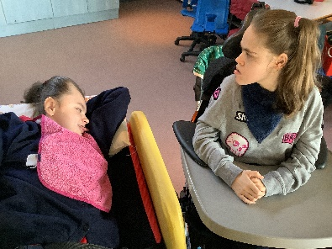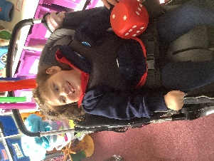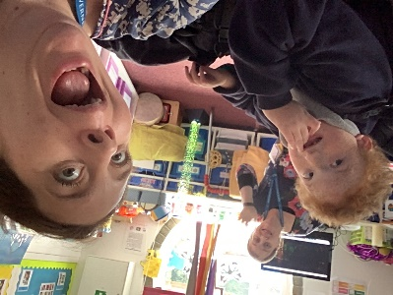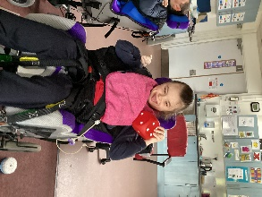

Responding to others taking par tin group games having fun and being silly! Showing anticipation

Physical

Includes:
- Fine Motor Operations
- Gross Motor Operations
- Physical development
Pupils are positioned for good health throughout the day following physiotherapy plans and guidance. They are also encouraged to develop body awareness, strength and movement in order to become more physically independent and to improve their functional skills and mobility. Pupils also develop ways of handling objects and exploring the world around them using fine motor skills.
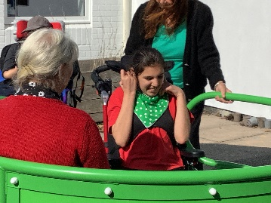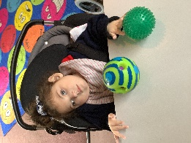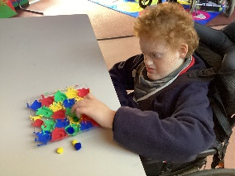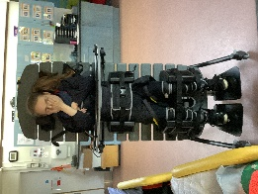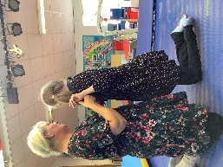

Using the wheelchair roundabout reaching and epxloring fine motor activities using my equipment rebound therapy

Sensory

Includes:
- Auditory
- Visual
- Tactile
- Proprioception
- Vestibular
Pupils are supported by school staff, with input from a wide range of therapists, to develop their auditory, visual, tactile, proprioceptive and vestibular skills through a wide range of daily activities. This further helps the pupils to make sense of the world around them.
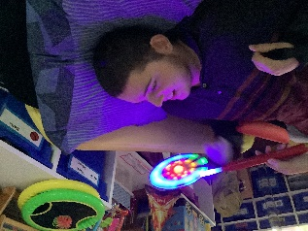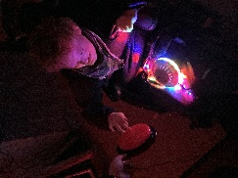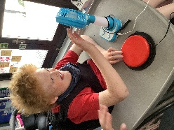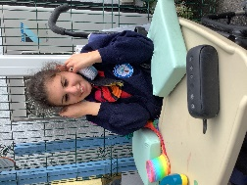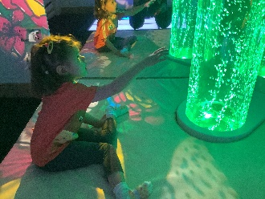
Visual impairment development using switches to experience sensations showing enjoyment to sound exploring the bubble tube in the sensory room

Assessment
Within our learning to learn pathway assessment can take many forms – however each pupil will have a personalised assessment map which is informed via their personalised learning profile. This assessment is then used to baseline current skills, knowledge and understanding is essential. This information is then used to inform future target setting and to inform future learning (learning remains part of a well-planned sequence).
This may include:
- Termly learning to learn profile review and update
- Individual pupil book – with termly ‘Then, Now, Next’ and ‘Magic moment’ pages (which celebrate achievement and progress)
- EHCP outcomes – termly PLG targets reviewed and annual review meeting with SENCo
- Multi-disciplinary meetings – may include TAC’s
Teachers also take part in the following – which feeds into assessment and offer/ curriculum review:
- Data and progress reviews, within performance management and line management meetings
- Learning walks
- Parents evenings
- Teaching opportunities
- CPD
- Moderation as a trust

