 Nancealverne School Music Offer 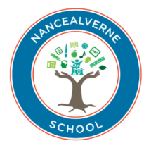
INTENT:
Our school Music offer is part of our Creative Arts cross-curricular school offer. We believe in the importance of pupils having the opportunity to experience live music performances with visiting musicians and choirs to school. Our pupils have the weekly opportunity to rehearse and sing and sign with a choir and experience performing in front of an audience; whether it is their friends or local community events. We provide the opportunity for all learners to perform and create music; regardless of their needs and abilities e.g. through the use of Clarion, an electronic instrument on the iPad that can be played with the movement of a musician’s eyes.
Our Music offer aims to develop pupils’ social, emotional, physical and well-being skills through the appreciation and creating of Music and to develop their attention and listening skills. Pupils will develop their music making and composing skills through the Music scheme “Charanga” which will develop and ensure their skills progression. Through the Music and Creative Arts curriculum and experiences, all pupils regardless of their needs will learn skills that enhance their fine motor and sensory skills, communication abilities, language, focus, independence, self-expression and confidence. Through First Access, pupils have the opportunity to learn to play an instrument such as the keyboard or guitar.

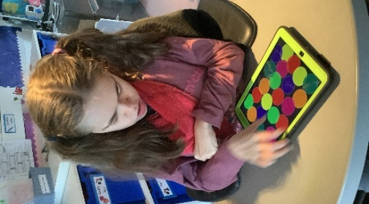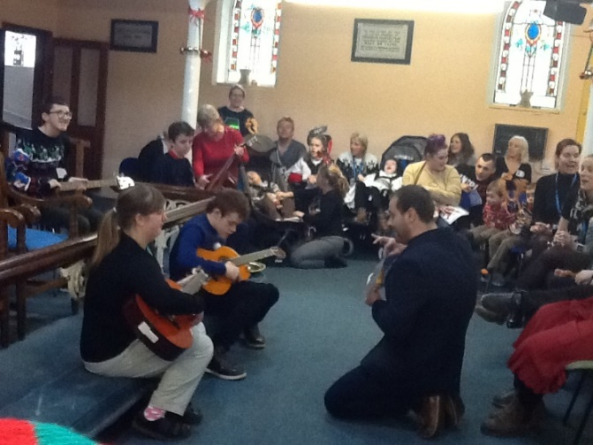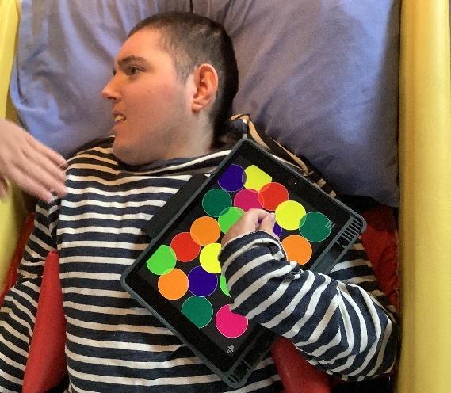

IMPACT:
Our Music curriculum is delivered through our cross curricular Creative Arts offer and allows all pupils to develop and enhance their performance in non-arts academic subjects such as mathematics, science, reading and writing. Music helps develop the skills needed to strengthen students’ academic motivation, self-confidence, and their ability to listen, communicate and co-operate effectively. Our choir and singing in class helps to develop pupils key signing as well as helping developing their cognitive and memory skills to remember lyrics and tunes. Communication and signing is promoted and developed with singing and signing sheets for the pupils to keep and practice with.
Our Choir and orchestra gives our pupils the opportunity to be part of a social group who meet weekly and also for older pupils to help lead and support by showing others the lyrics and signs as well as choosing the songs. They perform at community events and also whole school events such as the garden party to celebrate the Jubilee. Pupils show pride in being able to perform in front of their families and friends. Throughout school, Music is used to help pupils show how they are feeling and are given the opportunity to choose their own music in class. Music is even offered outside in our school; such as the drums and cymbals and glockenspiels in our outdoor sensory garden where children can choose to make music outside and explore different sounds and echoes.
Key Skills are assessed through BSquared for EYFS through to Key Stage 4 as well as Skills Builder and ASDAN Accreditation. Our pupils develop an understanding and appreciation of a wide range of different kinds of Music and techniques as well as listening to and learning about different musicians and composers. They can experiment and explore new sounds and ideas as well as further develop co-operation, tolerance and a willingness to work and perform with others. Pupils interact in different ways with instruments and develop their motor skills and co-ordination. Through our Music offer, an awareness of different cultures and traditions is developed; as well as pupils learning to express their feelings. By being involved in local Music projects and performances, they can explore and appreciate Music in the wider community. We perform regularly at a local care home to bring our music to the local community and improve our performance skills.

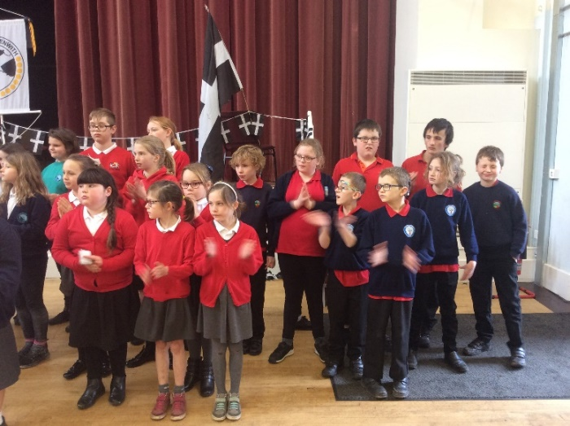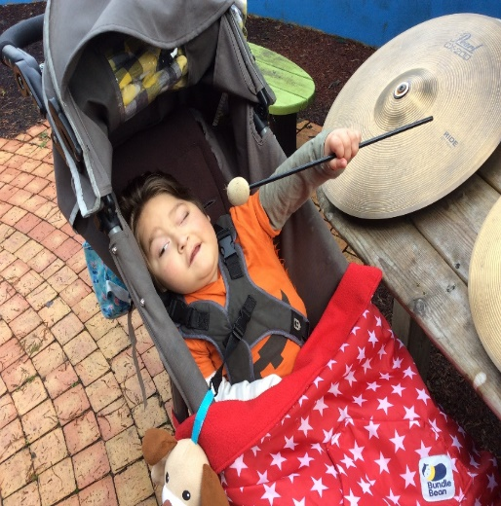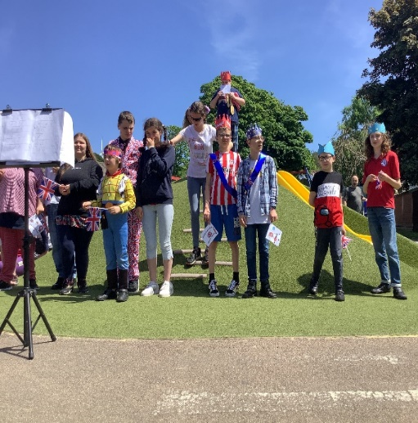
IMPLEMENTATION:
We have a school choir for pupils from Key Stage 1 upwards who practice together weekly. We also sing lots in the local community such as singing and signing events, busking, St Pirans events and rehearsing with other local schools. Some of the older pupils help to lead choir by teaching lyrics and signs as well as choosing songs for us to sing which helps to build their communication and language skills and their self-confidence. We have close links with the Penwith lead for the Cornwall Music Service Trust who always invites us and helps us access local school music events.
Music is delivered through our Creative curriculum throughout the school from Expressive Arts and Design in EYFS, delivered as a non-core subject from KS1 through to KS4 Post 16 where it will be accredited through ASDAN units where relevant. In Learning 2 learn and Bridging 2 learn curriculums, Music is woven throughout the school experience; both in routines and as discrete activities. Different music is used to help learners to understand the days of the week and musical sounds and cues to understand routines. Charanga schemes of work are used to show progression throughout the Key Stages. We also believe in the importance of live music and invite musicians and local choirs to come and perform as well as going out on school trips to watch performances. We also have a music therapist who visits weekly and works with individuals and small groups.
Open Access is used to help us hire different groups of instruments and a specialist music teacher who can come in and teach a small group of pupils an instrument. Music is also used for emotional wellbeing, e.g. lively music to dance and move to in weekly Zumba classes and Wake and Shake or relaxation and calming music for times in class such as TACPAC and sensory relaxation time. Exploring different sounds and musical styles is widely encouraged and also experimenting with making our own music through interacting with others, objects and instruments.



