School uniform policy
Nancealverne School
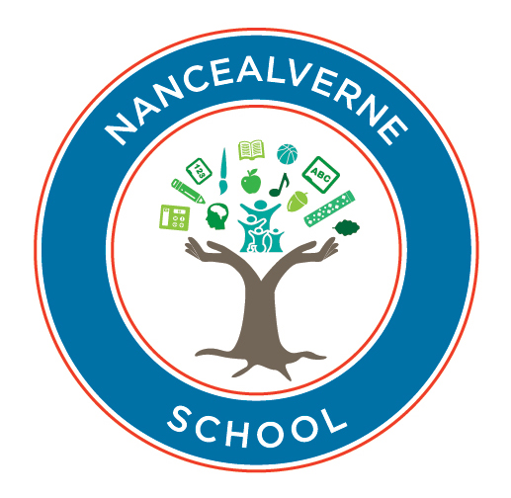

Approved by: | Ruth Carpenter | Date: March 2023
Last reviewed on:
Next review due by: | December 25

Contents
- Aims .................................................................................................................................................................................. 2
- Our school’s legal duties under the Equality Act 2010 ..................................................................................................... 2
- Limiting the cost of school uniform .................................................................................................................................. 2
- Expectations for school uniform ....................................................................................................................................... 3
- Expectations for our school community ........................................................................................................................... 4
- Monitoring arrangements ................................................................................................................................................. 5
- Links to other policies ....................................................................................................................................................... 5

1. Aims
This policy aims to:
Set out our approach to requiring a uniform that is of reasonable cost and offers the best value for money for parents and carers
Explain how we will avoid discrimination in line with our legal duties under the Equality Act 2010 Clarify our expectations for school uniform

2. Our school’s legal duties under the Equality Act 2010
The Equality Act 2010 prohibits discrimination against an individual based on the protected characteristics, which include sex, race, religion or belief, and gender reassignment.
To avoid discrimination, our school will:
Avoid listing uniform items based on sex, to give all pupils the opportunity to wear the uniform they feel most comfortable in or that most reflects their self-identified gender
Make sure that our uniform costs the same for all pupils
Allow all pupils to have long hair (though we reserve the right to ask for this to be tied back)
Allow all pupils to style their hair in the way that is appropriate for school yet makes them feel most comfortable
Allow pupils to request changes to swimwear for religious reasons
Allow pupils to wear headscarves and other religious or cultural symbols
Allow for adaptations to our policy on the grounds of equality by asking pupils or their parents to get in touch with Ruth Carpenter, Head Teacher, who can answer questions about the policy and respond to any requests

3. Limiting the cost of school uniform
Our school has a duty to make sure that the uniform we require is affordable, in line with statutory guidance from the Department for Education on the cost of school uniform.
We understand that items with distinctive characteristics (such as branded items, or items that have to have a school logo or a unique fabric/colour/design) cannot be purchased from a wide range of retailers and that requiring many such items limits parents’ ability to ‘shop around’ for a low price.
We will make sure our uniform:
Is available at a reasonable cost
Provides the best value for money for parents/carers we will do this by:
Carefully considering whether any items with distinctive characteristics are necessary
Limiting any items with distinctive characteristics where possible for example, by only asking the jumper worn over the T-Shirt features the school logo
Limiting items with distinctive characteristics to low-cost or long-lasting items, such as ties
Considering cheaper alternatives to school-branded items, such as logos that can be ironed on, as long as this doesn’t compromise quality and durability
Avoiding specific requirements for items pupils could wear on non-school days, such as coats, bags and shoes
Keeping the number of optional branded items to a minimum, so that the school’s uniform can act as a social leveler
Avoiding different uniform requirements for different year/class/house groups
Avoiding different uniform requirements for extra-curricular activities
Considering alternative methods for signalling differences in groups for interschool competitions, such as creating posters or labels
Making sure that arrangements are in place for parents to acquire second-hand uniform items
Avoiding frequent changes to uniform specifications and minimising the financial impact on parents of any changes
Consulting with parents and pupils on any proposed significant changes to the uniform policy and carefully considering any complaints about the policy

4. Expectations for school uniform
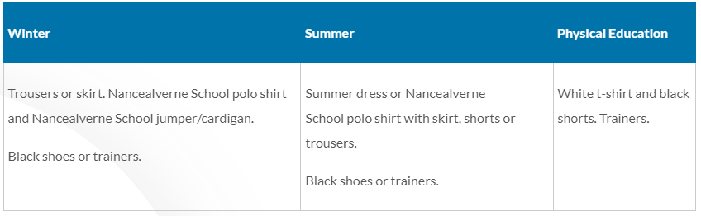
4.1 Our school’s uniform – All Pupils

Post 16
Uniform is not compulsory. If learners choose not to wear uniform they must adhere to the Special Partnership Trusts code of conduct.
If you do not wish to purchase the Nancealverne uniform we will allow pupils to wear plain royal or navy blue sweatshirts and polo shirts.
Please provide an appropriate T shirt, track suit /shorts and footwear for PE. A swimming costume and towel will also be needed. Your class teacher will advise you which day these are required.
All school clothing should be clearly named. We can then return it!

4.2 Where to purchase it
- Our uniform is supplied by Trophy Textiles, you can order online or you can phone them to place an order.
- Please contact our Family liaison team – Lauren Ladd or Steph Holmes (lladd@nancealverne.org.uk / sholmes@nancealverne.org.uk) if you need any support with information.

5. Expectations for our school community

5.1 Pupils
Pupils are expected to wear the correct uniform at all times (other than specified non-school uniform days) while:
On the school premises
Travelling to and from school
At out-of-school events or on trips that are organised by the school, or where they are representing the school (if required)
Pupils are also expected to contact the Head Teacher if they want to request an amendment to the uniform policy in relation to their protected characteristics.

5.2 Parents and carers
Parents and carers are expected to make sure their child has the correct uniform and PE kit, and that every item is:
Clean
Clearly labelled with the child’s name
In good condition
Parents are also expected to contact Heidi Hoskin Head Teacher if they want to request an amendment to the uniform policy in relation to:
Their child’s protected characteristics
The cost of the uniform
Parents are expected to lodge any complaints or objections relating to the school uniform in a timely and reasonable manner.
Disputes about the cost of the school uniform will be:
Resolved locally
Dealt with in accordance with our school’s complaints policy
The school will work closely with parents to arrive at a mutually acceptable outcome.

5.3 Staff
Staff will closely monitor pupils to make sure they are in correct uniform. They will give any pupils and families breaching the uniform policy the opportunity to comply but will follow up with the headteacher if the situation doesn’t improve.
Ongoing breaches of our uniform policy will be dealt with by the Senior Leadership team.
In cases where it is suspected that financial hardship has resulted in a pupil not complying with this uniform policy, staff will take a mindful and considerate approach to resolving the situation.

5.4 Governors
The governing board will review this policy and make sure that it:
Is appropriate for our school’s context
Is implemented fairly across the school
Considers the views of parents and pupils
Offers a uniform that is appropriate, practical and safe for all pupils
The board will also make sure that the school’s uniform supplier arrangements give the highest priority to cost and value for money, for example by avoiding single supplier contracts and by re-tendering contracts at least every 5 years.

6. Monitoring arrangements
This policy will be reviewed bi-annually by the Senior Leadership Team. At every review, it will be approved by the Senior Leadership team.

7. Links to other policies
This policy is linked to our:
Behaviour policy
Equality information and objectives statement
Anti-bullying policy Complaints policy

