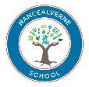 | Rationale for Maths at Nancealverne School

School Context
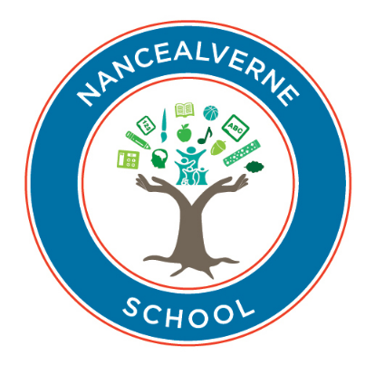
Nancealverne School is a specialist provision for students with special educational needs. We provide high quality, personalised education for young people aged 3-19 with a range of learning disabilities. Learners follow one of three pathways within our setting: the Pre-formal Learning Pathway, known as Learning to Learn, working with the Engagement Model; the Semi-formal Learning Pathway, known as Bridging to Learn, where students access the pre-requisites to learning and the early stages of the National Curriculum, and finally, the Formal Pathway, known as Ready to Learn, where our learners access a differentiated National Curriculum through more formal lessons and content.

Intent
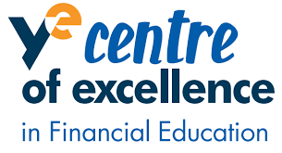
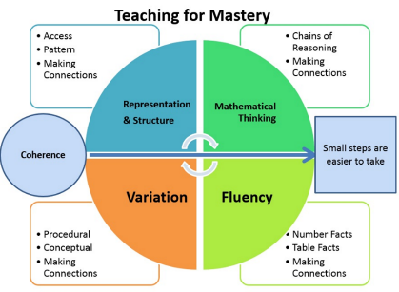
At Nancealverne, we believe maths to be a key life skill that supports pupils throughout their daily lives, at school, in the wider community and throughout their future lives. We aim to build all pupils’ skills in the fundamentals of maths, their fluency and ability to reason and problem solve, providing high quality, individualized learning opportunities that encompass pupils’ interests and preferred learning styles. Through a mastery approach, our maths offer ensures that all pupils have access to high quality teaching and learning of mathematics that encourages pupils to fully embed developed skills in their long-term memory, use the key vocabulary obtained appropriately and apply their learnt skills to solve problems within their everyday lives with greater confidence and fluency. In addition, we are a Financial Centre of Excellence, offering relevant, real-life opportunities for pupils to develop their financial understanding and prepare them for life outside school.

Implementation
Our maths learning encompasses 3 main areas: number (including calculation), measurement (including time and money) and Geometry, with an additional focus on financial understanding.
Maths is delivered both in discrete lessons throughout the week and holistically across each day, with all staff taking pains to ensure that opportunities for maths learning are maximised (both within structured and unstructured sessions).
Maths learning begins informally, through play, in our EYFS group, becoming more formal as we progress through the key stages. Maths is delivered as a core subject from KS1-KS4, underpinned through a mastery approach, with opportunities to gain formal qualifications (e.g. Asdan and Ed Excel Functional Skills) in KS4and KS5, as well as developing students’ preparedness for adulthood through application of skills to increasingly complex real-life situations.
Teaching and learning is highly personalised with individual pupil starting points taken into account and use of learning pathways to support progress. These pathways start with pre-formal learners (on our learning to learn pathway), who are taught holistically, moving through a semi-formal pathway (with a focus on topic based learning through multi-sensory play, games, TEAACH activities and rhymes/songs), to formal curriculum pathways (ready to learn), with a greater focus on discrete curriculum sessions.
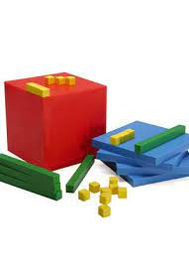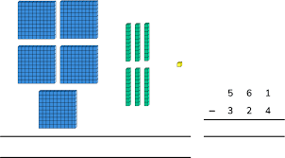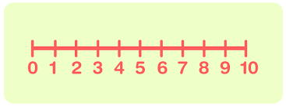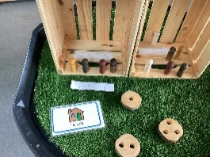
Within the pathways, all new learning begins with use and exploration of concrete resources (e.g. real objects, Numicon, Diennes blocks, shapes), moving to pictorial representations and structures (e.g. 10s frames, number lines, models and images), and on towards abstraction. This sequence is fluid and teaching moves between concrete, pictorial and abstract throughout learning sessions and units of work, ensuring that pupils are supported and learning is scaffolded to ensure maximum progress and challenge.
There is a focus on practical, engaging and fun lessons where pupils are encouraged to talk, share ideas and to focus on use of mathematical vocabulary to reason and explain. Communication opportunities are maximised in all sessions and learning supported through use of pictures, symbols, signs and AAC devices. Varied contexts are explored, taking into account pupils’ interests and using real-life scenarios and opportunities.
As part of our commitment to Financial Education, we operate a weekly school tuck shop in which pupils across the school are able to practice their money skills in a supportive, real life environment, whether purchasing items, shopping or cooking food or serving otherse. We also have a School Savings Bank, run weekly in conjunction with Kernow Credit Union, encouraging pupils to save regularly. Finally, we hold an annual Enterprise Week, in which we encourage all classes to research, make and produce items for sale at an end of week event. This always creates a really buzz around the school and offers valuable insights into the world of work as well as promoting financial skills (e.g. budgeting, keeping track of money, pricing, etc.).
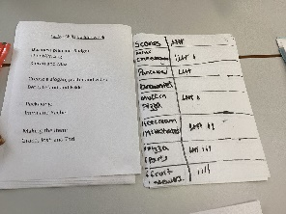
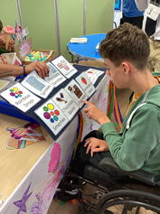
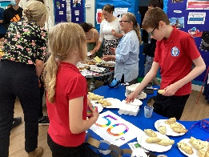
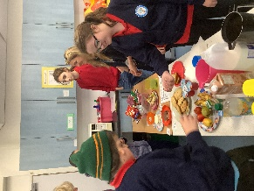

Progression of teaching and learning throughout the school
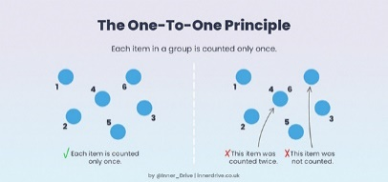
In EYFS and early KS1, there is a focus on learning through play, stories and songs using a range of indoor and outdoor contexts, including an outdoor mud kitchen and regular welly walks to observe changes in the local environment. Early number concepts such as subitising and the 5 counting principles are introduced alongside exploration of shapes, space, measures and early calculation using a range of motivating resources and activities, both structured and unstructured, with all pupils working towards the Development Matters Early Learning Goals.
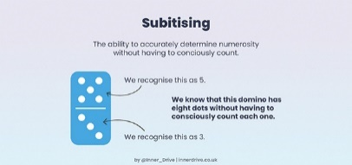
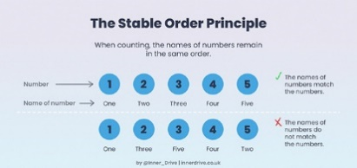

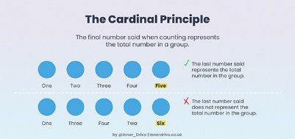
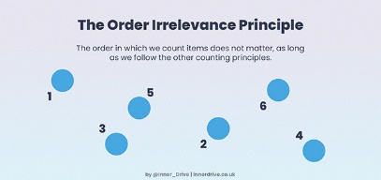
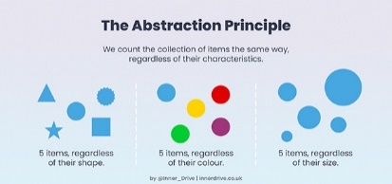

In Key Stages 1-3, there is a continued focus on individual starting points, but learning becomes more formal as students progress (in ready to learn cohorts). We use White Rose Maths and NCETM mastery frameworks and resources to support learning, but individual class teachers plan and deliver their own motivating ‘small step’ sessions with effective differentiation and use of appropriate resources, models and images.
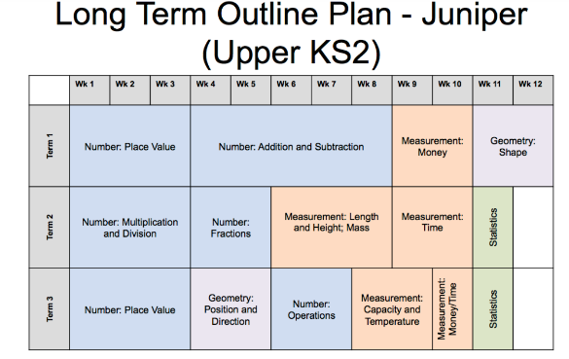
Example Long Term Plans (adapted from White Rose)
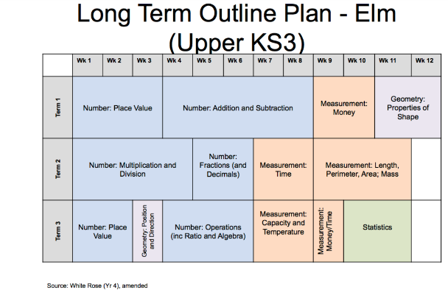
In Key Stages 4-5, pupils study functional Maths, focusing on opportunities to apply learned mathematical skills in increasingly wider contexts within the broad areas of number, measurement and geometry. The term ‘functional’ is considered in the broadest sense of providing students with the skills & abilities they need, encouraging growing independence and problem solving using real life contexts and situations. Sessions prepare them well for their next steps (whether on to college or community provision) and encourage pupils to take an active role in their communities, enabling them to become effective and involved citizens. Pupils work towards either ASDAN Accreditations, Ed Excel Functional Skills Entry Levels 1-3 and, if appropriate, Ed Excel Level 1 or 2 Qualifications.

Within the school we have additional learning bases that offer more specialist provision across year groups:

Pre-Formal Pathway (Learning to Learn):


Pupils in Maple class have complex health needs and need close support at all times. Pupils are primarily on the Learning to Learn Pathway and are taught holistically through termly topics. Within this structure, Maths learning is very much embedded into routines throughout the day - whether it be sequencing in sensory awakening, counting within PE, measuring skills in cooking sessions and DT, geometry in body awareness etc. However, short discrete maths sessions incorporating maths games/activities related to topic based work also offered.

Semi-Formal Pathway (Bridging to Learn):

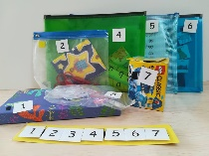
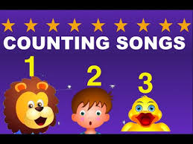
Pupils in Willow Class (Key Stages 3 and 4) benefit from a highly structured, multi-sensory learning environment that is focused on understanding and working to remove barriers to learning (such as anxiety), with a personalised offer that takes into account individual starting points. Maths learning is incorporated in activities across the day (from settling-in songs to sequenced activity strips) as well as in short, focused ‘burst, pause’ activities and use of TEAACH style resources.

Impact - Assessment of outcomes
At Nancealverne, the overwhelming majority of pupils make expected or above expected progress towards challenging targets.

Pupils’ learning is embedded and secure, enabling them to solve problems and to reason mathematically, preparing them effectively for the next stage of their learning and, ultimately, for life beyond school. Effective curriculum planning allows for smooth transition between key stages, with clear progressions mapped across the key stages.

Pupils leave school well prepared for the next stage in their lives, able to live as independently as possible within their communities. Ongoing formative assessment is supported by termly data collection and analysis to ensure that pupils’ progress is maximised through early interventions and additional challenge. Interventions are planned, monitored and assessed for both higher and lower attaining pupils to ensure that all pupils’ progress is optimal.

Progress in lessons and across the day is evidenced in individual pupil workbooks and/or via Evidence for Learning, producing learning journeys of pupils’ experiences and achievements.

EYFS use the Cherry Garden Assessment to assess progress and develop learning journeys using Evidence for Learning to evidence their progress within maths.

Key Stages 1-3 use B Squared Proprietary Assessment software to record and evidence progress, alongside work books and pictorial evidence (again through Evidence for Learning). Progress data is recorded termly through assigning levels of achievement (e.g. gaining skills, achieved, mastered) to progressive learning objectives (both pre and differentiated, small step National Curriculum objectives) on steps ranging from 1-10.

Pupils in Key Stages 4-5 work towards ASDAN Personal Progress Accreditations or Ed Excel Functional Skills Entry Level qualifications, with the opportunity to work towards Levels 1 and 2 Functional Skills or GCSE if appropriate.




