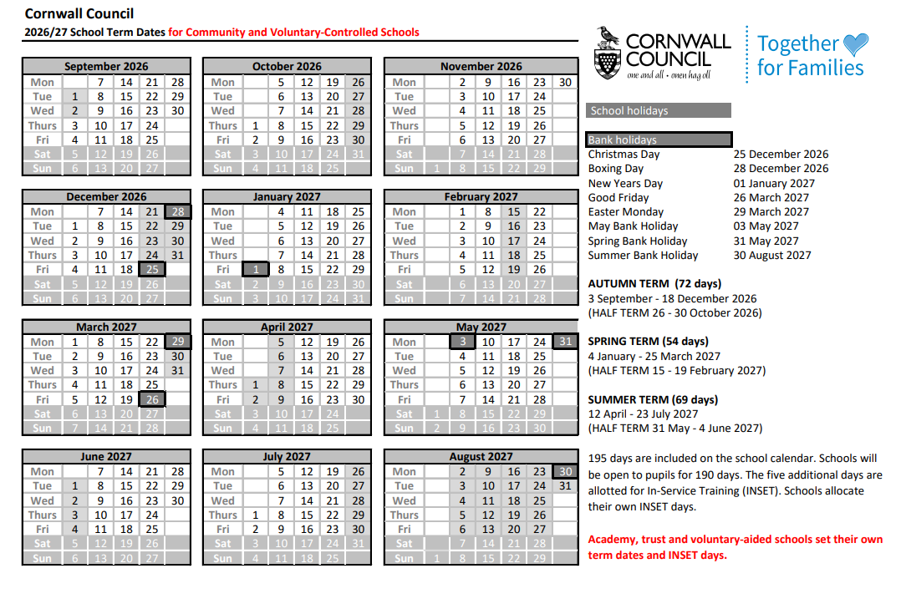
Inset Days
Tuesday 1st September
Wednesday 2nd September
Monday 4th January
Autumn Term
3 September – 18th December 2026
(Half Term 19 – 30 October)
Spring Term
4 January – 25 March 2027
(Half Term 15 – 19 February)
Summer Term
12 April – 23 July 2027
(Half Term 31 May – 4 June 2027)

