
Nancealverne School
(including upper School and Cury)
Health and Safety operational Processes policy
Reviewed September 2025
Organisation and Arrangements for Health Safety and Welfare.
The following pages contain the specific arrangements and organisational details for ensuring that Nancealverne School’s Health and Safety Policy is fulfilled.
Contents page of Health and Safety Policy
Statement of Health and Safety Policy 2
Responsibilities 3
1. Arrangements for the Supervision of Students 5
2. First Aid 6
3. Pupils with Medical Needs 8
4. Accidents/Incidents 11
5. Training 13
6. Risk Assessment 14
7. Fire 15
8 Electricity 17
9. The Control of Hazardous Substances 19
10. Display Screen Equipment 20
11. Work Equipment 21
12. Management of Contractors 22
13 Personal Protective Equipment 23
14 Working Alone 24
15 Violence 26
Appendix 1 – Roles responsibilities – roles and names of staff 27
Appendix 2- School evacuation plan 28

Statement of Health and Safety Policy

Nancealverne School:-
- Recognises its legal and moral responsibilities to persons who may be adversely affected by the school’s activities.
- Is committed to ensuring, by all reasonably practical means, the health, safety and welfare of its students, visitors, employees and contractors involved with its activities.
- Will seek to ensure that its legal duties and policy objectives are complied with at all times.
- Will ensure that all foreseeable risks associated with the school’s activities are identified and removed or controlled through a process of risk assessment and management.
- Will ensure that all employees are given such information, instruction and training as may be necessary to enable the safe performance of their duties.
- Will seek to inform students’ parents or guardian of any health, safety or welfare issues relevant to their child or children.
- Have detailed the arrangements for health safety and welfare in the Organisation and Arrangements associated with this policy statement.
- Will ensure, as far as is reasonably practical, that this policy statement and supporting documents are kept up-to-date. A formal review and re-adoption of this policy will be carried out by no later than September 2026.

Approved and adopted by:
Chair of Governors |  | Head Teacher/Principal

On: September 2025

Responsibilities
It is recognised that individuals and groups of individuals have responsibilities for health safety and welfare in the school. The individuals and groups identified below are expected to have read and understood the school’s policies and procedures for ensuring health safety and welfare and to conduct their duties in accordance with them.

The employer
The employer in this school is the Special Partnership Academy Trust. The employer has the ultimate responsibility and must ensure that there are arrangements in place for the health safety and welfare of students, staff, visitors and contractors.

Trustees
The Trustees are responsible for ensuring that mechanisms and procedures are in place for health safety and welfare. The Trustees will receive regular reports to enable them, in collaboration with the Headteacher to prioritise resources for health safety and welfare issues.
The Trustees have appointed a Safety Governor to receive information, monitor the implementation of policies, procedure and decisions and feed back to the Trustee Board on health safety and welfare issues.
The Trust Health and Safety lead is: John Rail
The local Governing Body lead is: Roy McDiarmid
Head Teacher
The Head Teacher has responsibility for:-
- Day-to-day management of all health safety and welfare matters in the school in accordance with the Statement of Safety Policy;
- Ensuring that regular health safety and welfare inspections are carried out;
- Submitting regular health safety and welfare reports to the Governors and the employer;
- Ensuring that action is taken on health safety and welfare issues;
- Passing on information received on health safety and welfare matters to appropriate people;
- Carrying out accident investigations;
- Chairing the school Health and Safety group
- Identifying and facilitating employee training needs;
- Liaising with Trustees, governors, the employer and/or the Local Authority on policy issues and any problems in implementing the Safety Policy;
- Co-operating with and providing necessary facilities for trades union safety representatives;
- Providing necessary facilities for all employees to be consulted on health safety and welfare matters;
- Ensuring that any contractor appointed to deliver services or carry out work is competent to do so;
- Monitoring contractors to ensure that the Health and Safety Policy is complied with;
- Take action where any contractor is found to be working in a manner which is considered to be unsafe.
Whilst responsibility for the above cannot be delegated, the function of carrying out these tasks can be delegated to other members of staff. In this the following functions have been delegated to:-
Function | Delegated to
Day to day health safety and welfare management | Premises Supervisor
Regular inspections | Premises Supervisor and Caretaker
Accident Investigation | Headteacher, Assistant Headteacher and Premises Supervisor.
Chairing Health and Safety Group | Headteacher
Employee training needs | Assistant Headteacher
Contractor management | Premises Supervisor

Competent Health and Safety Advice
Nancealverne School must have access to competent health and safety advice. The school’s competent advisors are
The Health, Safety and Wellbeing Services Team, Cornwall Council

Senior Management, Middle leaders and leads with responsibilities
These role have responsibilities for:-
- Day-to-day management of health safety and welfare in accordance with the Health and Safety Policy;
- Drawing up and reviewing departmental/curricular area procedures regularly;
- Ensuring that suitable risk assessments have been carried out for all activities where there is a significant risk;
- Carrying out regular inspections and making reports to the Headteacher
- Ensuring action is taken on health safety and welfare issues;
- Arranging for employee training, information and instruction;
- Passing on health safety and welfare information received to appropriate people;
- Acting on reports from employees, the Head Teacher; the Governors and the Local Education Authority.

All Employees
All employees have a general responsibility, as far as reasonably practical, to ensure the health safety and welfare of themselves and others who may be affected by anything they do or fail to do. In particular employees have a responsibility for:-
- Checking that classrooms/work areas are safe;
- Checking equipment is safe before use;
- Ensuring safe procedures are followed;
- Ensuring protective equipment is used when needed;
- Participating in inspections and the Health and Safety Committee/group if appropriate;
- Bringing problems to the relevant manager’s attention.
In addition all employees have a responsibility to co-operate with the employer on matters of health and safety.

Volunteers
Volunteers (such as parent-helpers, etc.) have a responsibility to act in accordance with the [school/academy]’s policies and procedures for health safety and welfare and to report any incident or defective equipment to a member of staff immediately.
Volunteers are also expected to act only under the supervision of a qualified employee.

1. Arrangements for the Supervision of Students

Opening Times
The School will be open from:-
Students arrive from 9:10 and the school days starts at 9:15am.
And will close to students at:-
3:25pm where students are safely transferred to awaiting transport.

We are open weekdays during term time.
Between these times supervision will be provided. Students will not be allowed on site outside of these times.

Supervision arrangements
Supervision is in classrooms at the start of the day. Staffing is based in class and learner needs. Minimum ratios are two adults per room but most are much higher than this often ratios ranging from 2:1 to 1:5.
All classes have additional midday supervision to ensure rations remain high during lunchtime periods.
High and appropriate levels of supervision are expected at all times and in locations around the school site.
Learners are collected and handed over to parents/ carers and transport providers at the front of the school at the beginning and end of each day. No learner is unsupervised at these times.
Where learners who are not collected at the end of the day we would make contact with the parent/carer to find out what has happened. We will supervise until alternative safe arrangements can be made. If we are not able to make contact or if arrangements for collection cannot be made within 30 mins of the school day then we would follow of safeguarding protocols and we would contact social care for advice.
After School Lettings
Unless specifically agreed in the Letting Agreement the School does not provide supervision for any groups using its facilities as part of a letting/hiring arrangement.

2. First Aid

Assessment of Needs
An assessment of first aid needs has been carried out and has identified that the following numbers of trained staff is required:-
First Aid at Work Qualified 8
Emergency Aid Qualified 8
Paediatric First Aid Qualified 8

All of our staff class based staff undergo basic aid awareness training.

First Aid Coordinator
The first aid Co-ordinator’s responsible for overseeing the arrangements for first aid with the School.
These duties include ensuring that:-
- First aid equipment is available at strategic points in the School (these are appropriately stocked and in date)
  - Posters around the school clearly show the locations where these can be found.
They also include ensuring that:-
- A sufficient number of personnel are trained in first aid procedures
  - Lists of trained first aiders are on the school posters, dates of training and level of qualifications are retained and monitored
- First Aid qualifications are, and remain, current.
The health and safety working group will also regularly check first aid logs for indications of recurrent or frequently reported types of injury. This is reported to our local governing body via the Headteacher’s Report.

First Aiders
The first aiders listed on the posters will provide first aid treatment for anyone injured on site during the school day. They will also provide, as appropriate, first aid cover for:-
- Trips and visits
- Extra-curricular activities organised by the School (e.g. sports events, after School clubs, parents’ evenings, School organised fund raising events etc.)
First aid cover is not specifically provided for:-
- Contractors
- Events organised by third parties (fetes, evening clubs, etc.
First Aiders are responsible for ensuring that First Aid Logs are completed for all treatment given and that the necessary details are supplied for the reporting of accidents (see Reporting of Accidents section)
School nurse
We also have a school nurse on our school site. Their role is to work with children and young people who have varying levels of learning disabilities and complex health needs. They support us with training and practical advice and support to ensure we are supporting and meeting the complex medical needs or our learners. They oversee the controlled medication procedures on site.
The school nurse works as a member of our school team and works with social care and other health professionals to ensure that the health needs of children and young people are met.

Treatment of Injuries
The School will rely on the knowledge and experience of its trained first aiders, with support when available from our school nurse, in order to administer appropriate treatment to injured persons.
In emergency situations the first aider will call (or instruct another member of staff to call) 999 and request that an ambulance and paramedics attend.
Where there is any doubt about the appropriate course of action the first aider will be expected to consult with the Health Service Helpline
111
And, in the case of student injuries, with the parents or legal guardian.

Suspected Head, Neck and Spinal Injuries to Students
In the event of a suspected head, neck or spinal injury to a student it is the policy of this School, in addition to the normal first aid procedures, that the student’s parent/guardian is contacted and informed of the injury.
The attending first aider, in consultation with the parent/guardian, will decide the appropriate course of action in each case. The first aider will ensure that treatment is not delayed by difficulties in contacting the parent/guardian.
In any case where there is any doubt about the student’s wellbeing, the first aider is expected to contact the Health Service Helpline for advice or phone for an ambulance as appropriate.

Other Significant Injuries
Any other serious injury will be notified to the parents/guardians by the quickest means possible (normally by phone).
In addition to the procedures above the school will notify parents/guardians of any other significant injury by way of:-
- A telephone call and or a duplicate first aid slip
- Records of notification by telephone to parent/guardians will be recorded in the first aid log book. Copies of written notification are held the first aid room.

Escorting Pupils to Hospital
When it is necessary for a student to be taken to hospital they will be accompanied by a member of staff – unless the student’s parent/guardian is in attendance.
The member of staff will stay with the student until a parent/guardian arrives and responsibility is transferred.

3. Pupils with Medical Needs
The school recognises that it has a responsibility to support pupils with medical needs. The School follows the Department for Education’s guidance on managing medicines in schools and early years settings:-
(https://www.gov.uk/government/uploads/system/uploads/attachment_data/file/484418/supporting-pupils-at-school-with-medical-conditions.pdf)
Please also read the Trust’s policy ‘Managing Medications in School’.
Responsible Person
The Assistant Headteacher supported by the school nurse are responsible for ensuring that the arrangements below are effectively implemented and maintained.
Medicine in School
Medicines will only be administered at school when it would be detrimental to a student’s health not to do so. The school will store and dispense medication to students as long as:-
- It is prescription medication which has been prescribed by a medical practitioner with written instructions for its use; or
- It is non-prescription medication which has been supplied by the parent/guardian with written instructions for its use; and
- Written parental consent has been given and must be in the original packaging.
- The school does not keep or dispense any other medication other than salbutamol for use with the emergency asthma kit (see below).
Medication brought into school must be clearly labelled with the student’s name, dosage, method of administration and be in-date.
Medication will be available to identified students at all times of the school day.
There is a log of all medication that has been administered.
Self-Management of Medication
In certain circumstances the school will allow students to manage their own medication. In each case this will be discussed with the parent/guardian and appropriate health professionals - and an assessment of risk will be completed and this will be signed for by parent/carers.
The assessment of risk will include an evaluation of the risk to the student and others through inappropriate use of the medication, loss of the medication or failure to take the medication]

Emergency Asthma Kits
This School’s procedures for managing the use of the emergency asthma kit is based on Department of Health guidance:-
https://www.gov.uk/government/uploads/system/uploads/attachment_data/file/350640/guidance_on_use_of_emergency_inhalers_in_schools_September_2014__3_.pdf
Staff authorised to dispense this medication have read the above guidance and have been given instruction in the recognition of the symptoms of an asthma attack and the appropriate procedures to follow.
The emergency inhaler contains Salbutamol and will only be available to students who have been
- diagnosed with asthma and prescribed an inhaler OR
- prescribed an inhaler as reliever medication.
In addition signed parental consent must be obtained for use of the emergency inhaler.
The school keeps a register of students who have been diagnosed with asthma or prescribed a reliever inhaler.
The emergency asthma kit will be stored and managed in the same way as any other prescription medication following the procedures above.
Storage of Medicine
Medicines will be securely stored in medicines cabinets in classroom, controlled medications are securely stored in the school nurse’s room.
All medicines must be signed in in the Medicines Log.
Any medicine given out or administered must be recorded in the Medicines Log.
All medication handed to the school is signed for at the point of transfer.
Medicines can only be given out by staff who have received medication training.
Facilities for Medical Procedures
A room has been provided for medications and medical treatments to be administered which is in the school nurse’s room.
Training
The responsible person will ensure that sufficient staff are suitably trained in the administration of medication and support of students with medical needs.
The responsible person will keep a record of all medical needs training.
Sharing of Information
The school nurse and the responsible person will ensure that relevant staff are made aware of any student’s medical condition. This information will include, where appropriate:-
- Medical condition
- Side effects of medication
- Signs and symptoms
- Modifications and allowances
- Emergency actions
The responsible person will also ensure that relevant information is shared with cover staff etc.

Individual Healthcare Plans
The responsible person will work with (or identify an appropriate member of staff to work with) healthcare professionals and parent/carers to establish an effective healthcare plans where appropriate.
Healthcare plans will be reviewed if there is reason to suspect that the plan is no longer appropriate and at least annually. A healthcare plan review can be initiated by the school, healthcare professional or the parents/carers.
Risk Assessment
In addition to the healthcare plan the school will carry out individual risk assessments for any student where the student’s medical needs introduce new risks to an activity or increase existing risks that are not covered in their health care plans. This will include (but may not be limited to) individual risk assessments for off-site activities, sporting activities and practical lessons.
Risk assessment for off-site activities, in particular, will include consideration of:-
- Access to medication
- Appropriate storage of medication
- Staff training in administration of medication
- Emergency procedures

Unacceptable practice
To prevent unacceptable practice the responsible person will ensure that:-
- Students have access to their medication at all times during the school day or during educational activities off-site.
- Healthcare plans reflect the needs of the student and take into account the views of parents/carers and advice of healthcare professionals
- Every effort is made to ensure that students with medical needs are able to stay in school for normal school activities (including lunch) unless there is a specific reason detailed in their healthcare plan not to do so.
- If the student becomes ill; ensure that he/she is accompanied to the school office/medical room by an appropriate person.
- Students with medical needs are not penalised in their attendance record if their absences are related to their medical condition, hospital appointments, etc.
- Toilet, food and drink breaks are provided where necessary in order to manage a student’s medical condition.
- Arrangements for administering medication do not include the need for parent/carers to attend school.
- Every effort is made to ensure that students with medical needs are able to take part in every aspect of school life including off-site activities, sporting events and practical lessons.

Complaints
Parents/carers are encouraged to contact the school nurse or the child’s class teacher if they are concerned or dissatisfied in any way with the support provided by the school for a student with medical needs.
If concerns cannot be resolved in this manner; parents/carers can escalate to the Headteacher, and they can also follow the school’s complaint procedure.

4. Accidents/Incidents

Reporting Officers
Admin staff and SLT have access and authority to report accidents and incidents.
Staff are required to report all accidents/incidents to a reporting officer within a reasonable timescale.
Students are required to report all accidents/incidents to a member of staff.
The Reporting Officer will record incidents using the systems below.

Accident/Incident Reporting Systems
This School records all significant accidents and incidents using the Cornwall Council Online Accident Reporting System. (AssessNet) A significant accident is:-
Any incident resulting in an injury to a member of staff; it must include all incidents where external medical advice is sought eg GP or hospital or where a staff is absent from school due to the injury.
Any incident resulting in an injury to a visiting member of the public
Any incident resulting in an injury to a contractor on the school site
Any incident resulting in an injury to a student which was (or might be) due to
- The condition or layout of the premises or facilities
- The condition of any equipment in use
- The level (or lack) of supervision
- The level or quality instruction or training provided
Any “Dangerous Occurrence” as listed in the schedule to the Reporting of Injuries Diseases and Dangerous Occurrences Regulations (RIDDOR)
Any “Occupational Disease” as listed in RIDDOR.
Further guidance on what should be reported is available through the Online System or the School Messenger website.
Where the description of the accident/incident meets the criteria set out in RIDDOR a report will be sent to the Health and Safety Executive. The local authority Health and Safety Duty Safety Officer carries out this function on behalf of the school.
Any minor accident/incident which does not meet the above criteria will be recorded on a simple “in school log book” which will be kept in the school.
Pupil first aid log is located in the nurse’s room
Staff accident book is in the front reception.

Near Misses
Where an incident occurs which could have resulted in injury – but didn’t – a record will be kept in a Near Miss Log.
The Near Miss Log is kept in the front reception. AssessNet can also be used to record near misses.
All Near Miss Logs are reviewed by the Headteacher and will be reviewed termly by the local governing body. In order to identify any areas of concern which may require attention.

Reporting Timescales
 | Reporting timescale
Students will report accidents/incidents to a member of staff | Straight away if possible and in any case on the same day as the incident
Staff will report accidents/incidents to a reporting officer | Straight away if possible and in any case on the same day as the incident
Reporting Officers will complete the online report | Usually within 48 hours and all cases within 5 days.

Accident/Incident Investigation
All incident reports will be reviewed by our Premises Supervisor and/or our Behaviour lead who will decide if an internal investigation is necessary. Investigation reports will be entered onto the Online Accident Reporting System. Significant incidents as determined by the above two staff will be reported to the Head Teacher; the Health and Safety Local Governor and the Trust Health and Safety Leads.
All reports submitted via the Online Accident Reporting System are reviewed by the Health Safety and Wellbeing Services Team of Cornwall Council.
Health Safety and Wellbeing Services will recommend an independent investigation of the accident/incident if the review indicates a need. The Trust Director will decide if this investigation takes place

5. Training

Identification of Training Needs
The School will carry out an evaluation of the health and safety training needs of staff. The Cornwall Council Training Matrix for Schools and Other Educational Establishments will be used as the starting point of this evaluation.
A prioritised plan for delivery of training will be put in place to where the evaluation identifies a need.
Our CPD lead is responsible for carrying out the evaluation of training needs and presenting recommendations to the Headteacher and the Governing Body.

Staff Responsibilities
Staff must attend health and safety training provided by the school.

6. Risk Assessment

Risk Assessment
The School will seek to identify all activities and situations where there is a likelihood of significant risk. Significant risks will be assessed and controls will be introduced to remove or reduce those risks.

Risk Assessment Process
The school will carry out risk assessments using AssessNet
Ruth Carpenter is responsible for managing the risk assessment process for education related activities.
Gareth Gittins is responsible for all site and premises risks assessments. Due to the nature of reactive maintenance, it is agreed that dynamic risk assessments are permitted where necessary.
Both will produce relevant reports for the Governors.
Copies of risk assessments are available from our Office Manager in the school office.

Staff Responsibilities
All staff are required to support the risk assessment process.
Staff identified with responsibility for activities are required to carry out or lead the risk assessment process for those activities.
Class teachers/ Subject/ area leads/ educational visit leads are responsible for ensuring that risk assessments have been completed for all activities where there is a significant risk.

Safe Working Procedures
Where appropriate risk assessments will be used to develop safe working procedures. These safe working procedures will form the basis of the school’s normal operating procedures. Copies of safe working procedures are available from our Officer Manager.

7. Fire

Fire Control Officer (FCO)
The person responsible for / having control of the premises is the Head Teacher (Ruth Carpenter).
Fire safety Manager
Day to day operational responsibilities are designated to the premises supervisor (Gareth Gittins).
The premises supervisor is responsible for:-
- (In Co-ordination with the FCO) Arranging a fire evacuation drill at the beginning of the academic year and at least once every term (once per half-term where practical)
- Recording the significant results of the fire evacuation drills
- Feeding back the school’s performance during evacuation drills to management and other relevant persons.
- Ensuring that the Fire Log is kept up-to-date (arranging from alarm tests every week, emergency lighting every month, fire extinguisher checks, etc.)
- Ensuring that a fire risk assessment is carried out and periodically reviewed.
- Reporting to the Head teacher on issues of significance.
Fire safety compliance
The premises supervisor will manage the following compliance inspections and ensure the every software is up to date:-
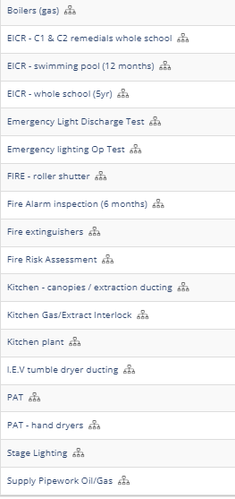

All Staff
All staff are responsible for ensuring that students and visitors evacuate in an orderly and timely fashion in the event of the alarm sounding.
Staff are also responsible for ensuring that they:-
- Do not store combustible materials in escape routes or against sources of combustion
- Do not leave fire-doors wedged open (when the room is unoccupied)
- Do not misuse any equipment provided for fire safety
- Report any defect in equipment provided for fire safety
- Report any fire hazard.
Fire Wardens
The school has identified Fire Wardens for areas of the school (Please see appendix 2 for current list of roles and responsibilities).
Fire Wardens have received training in fire prevention, the principals of fire safety, safe use of firefighting equipment and effective evacuation procedures.
Periodically Fire Wardens will carry out inspections of their area of the school to identify fire hazards and any other fire safety related issues. These inspections will be reported to the Fire Officer or senior member of staff for action.
In the event of a fire, Fire Wardens will assist in the evacuation of the premises by:-
- Checking that their assigned areas have been evacuated(if it is safe to do so)
- Supervising and directing students and staff to areas of safety.

Fire Fighting Equipment
Firefighting equipment has been positioned at appropriate positions around the site.
In accordance with the Regulatory Reform (Fire Safety) Order a number of staff have been given training in the use of firefighting equipment:-
Due to the specialised nature of the wet chemical extinguisher located in the school kitchen, catering staff are required to undertake bespoke training for its use.
Emergency plan
Should the building be deemed unsafe following a fire incident then staff and pupils are to report to Pensans school for safe refuge.

In appendix 2 please find attached the school’s evacuation plan which includes:
- Assembly point plans / procedures
- Evacuation plan – roles and responsibilities
- Fire alarm panel procedure
- Fire leaflet for visitors
- Call point site map
- Fire alarm plan
- Fire escape route plan
- Fire procedures – office staff

8 Electricity

School Owned Portable Appliances
The school will undertake to inspect and test all its portable electrical appliances by a competent person on the following basis:-
Annual Tests will be carried out by our current service provider (PPL electrical services)
All test Certificates will be kept electronically by the premises supervisor and uploaded on to the Every system.
Ad hoc testing will be carried out by our local electricians (ER Jenkins).

Personal and Privately Owned Portable Appliances
Personal items of electrical equipment may only be bought into the school/academy by prior agreement. Equipment must be presented to the Premises Supervisor for testing to be arranged prior to use.

Hand dryers
Although hand dryers around the school are fixed appliances from fused spurs, due to the exposed flex from the unit to the spur they must be treated as portable appliance. Due to the fused spur a separate annual PAT will be carried out by our local electricians (ER Jenkins) on these items.

Portable heaters
Portable heaters are not permitted in communal areas, classrooms or any space that pupil’s access.
Portable heaters are permitted in office spaces, only when absolutely necessary and provided the following conditions are adhered to:-
Only heaters with closed heating outlets (no exposed elements, fan heaters or halogen type heaters) can be used. The preferred heater type being oil filled electric radiators.
It is the user’s responsibility to perform a visual check prior to use of the plug top, flex and overall body of the heater for any signs of excessive wear / damage. If any found, the unit must not be used and it should be handed to the site supervisor for repair / disposal.
It is the user’s responsibility to ensure the flex of the heater does not present a tripping hazard, nor that the flex is put under excessive strain.
It is the user’s responsibility to ensure the heater is turned off at the end of each day / end of shift.

Extension leads
The use of extension leads must be avoided at all times where possible. “daisy-chaining” of extension leads in strictly prohibited.
Where the use of extension leads are unavoidable the flex must be securely clipped until a fixed wiring option can be priced and installed.

ECIR (Electrical condition inspection reports)
Every 5 years an ECIR will be carried out across the entire school.
Every 12 months an ECIR for the swimming pool board shall be carried out
All reports will be held electronically on the premises supervisors drive space and uploaded onto the Every system
All code 1 defects will be addressed immediately by the contractors
All code 2 and 3 defects will be priced ASAP with all code 2 defects being rectified following pricing being obtained. Where possible and deemed economically viable all code 3 defects will also be addressed.

Stage lighting
Stage lighting will be inspected for electrical safety every 12 months, all fail safe cables/chians etc will also be checked.

9. The Control of Hazardous Substances

Hazard Assessment
All substances which may be considered hazardous to health under the Control of Substances Hazardous to Health (COSHH) Regulations must be assessed using Cornwall Council’s COSHH Assessment Process. This is to be carried out using the SYPOL online software used across the Trust.
The exception to this is for substances and preparations used in Science – these substances and preparations are used in accordance with the Hazcards provided by the Consortium of Local Education Authorities for the Provision of Science Services (CLEAPSS).

Staff Responsibilities
Staff shall not use any hazardous substance without first having read the COSHH Assessment (or Hazcard in Science).
Staff shall inform the COSHH Coordinator (Premises supervisor) of any new hazardous substance purchased in order that an assessment can be made prior to use.

COSHH Coordinator (premises supervisor)
The premises supervisor is responsible for ensuring that, before any new substance/chemical is used, a COSHH assessment has been obtained from Cornwall Council.
This role is responsible for ensuring that COSHH assessments are seen and understood by those staff who are exposed to the substance/preparation.
The Coordinator is also responsible for ensuring that any updated COSHH assessments received are seen and understood by those who are exposed to the substance/preparation and that the COSHH file is kept up-to-date.
The Coordinator is responsible for ensuring that COSHH assessments are also obtained from contractors on site (both regular contracts such as cleaners and caterers and from builders, decorators, flooring specialists, etc.) where persons may be affected by their use of site or the storage of such substances/preparations may need to be controlled.
In addition, any hazardous substances or preparations being used by visiting artists, crafters, etc. must have appropriate COSHH assessments before being used in the school.

10. Display Screen Equipment

Workstation Assessment
Premises Supervisor is responsible for overseeing the assessment of all display screen equipment (DSE) used by people at work (i.e. excluding student workstations) to ensure that it is suitable for the task and complies with legislation and the relevant British Standards.
Equipment
Appropriate DSE equipment will be provided as identified by workstation assessments.
Eye Tests for Display Screen Equipment Users
All school employees who are defined as display screen equipment (DSE) users are entitled to a free eye test and special glasses for use with DSE.
DSE users are defined as:-
- Employees who use display screen equipment as a significant part of their normal work; and
- Use DSE for continuous or near continuous spells of an hour or more at a time; and
- Use it in this way more or less daily; and
- Have to transfer information quickly to or from the display screen equipment; and
- A requirement to apply high levels of attention and concentration; or are highly dependent on DSE or have little or no alternative means of completing the work/task.
(Agency staff and other people at work in the school should contact their own employer for details of arrangements that apply to them).
If staff request an eye test they need to make contact with Office Manager who will contact the Trust for further details.

11. Work Equipment

The premises supervisor is responsible for overseeing the purchase of all work equipment with admin ordering support from the admin team.
All work equipment must be purchased from a reputable supplier for the type of equipment that is required. Before purchase consideration must be given to:-
- The installation requirements
- The suitability for purpose
- The positioning and or the storage of the equipment
- Maintenance requirements (contracts and repairs)
- Training and use of the equipment
Staff must not use new items of work equipment unless appropriate training has been given.

12. Management of Contractors

The premises supervisor is responsible for overseeing the management of all contractors on site.
Selection of Contractors
The school will only select contractors to carry out work who have demonstrated:-
- Competence to carry out the work required (by way of training, knowledge and experience)
- Assessment of the risks associated with the work
- A safe scheme of work
- Appropriate management of the work
- Appropriate vetting procedures for their employees where appropriate
- Appropriate employers and public insurance

Management of Contractors
Supervision of contractors will, to an extent, depend on the type of work being carried out:-
- New contractors or contractors visiting the site on a one-off basis will be directly supervised by a member of school staff.
- Term contractors or regular contractors to the site will only be allowed unsupervised access following appropriate checks and assurances from the employer.
- Permit to work will be issued where necessary.
All contractors will be required to carry visible identification.
Direct supervision will not be necessary where the area of work is physically separate from the school (for example: where there is construction on site).

Construction Works
For all construction works (other than minor maintenance works) the area under construction will be physically separated from the rest of the school and will be out-of-bounds to all non-construction workers except for the purposes of contract management.

13 Personal Protective Equipment

Responsibilities
Personal protective equipment (PPE) will be supplied to control hazards only as a last resort – i.e. where the hazard cannot be removed or reduced to an acceptable level of risk by other means.
Where provided the school has a duty to ensure that PPE is used effectively. Managers will be expected to monitor the use of PPE and enforce its use where necessary.

Assessment of Need
The need for PPE will be determined during the Risk or COSHH Assessment process.
Where identified as necessary PPE will be provided without cost to staff or students.

Purchase and Storage of PPE
The admin team are responsible for the purchase of PPE ensuring that it is of the correct type, is suitable for the purpose and of the correct size to ensure that the fit is comfortable for the wearer and takes account of any health or medical conditions.
In addition the premises supervisor will ensure that suitable arrangements are in place for the storage, cleaning and replacement of PPE.

Staff and Student Responsibilities
When issued with PPE; staff and students are required to wear it correctly.
Staff must take all reasonable precautions to ensure that PPE is stored and maintained properly.

14 Working Alone

It is recognised that, from time to time, it may be necessary for school staff to work in situations or locations which are remote from other members of staff. This will include staff working in the evenings, weekends or during the holiday in the school on their own.
In such circumstances the school will assess the risk to these individuals and will introduce suitable controls to ensure that all risks are minimised. A copy of the procedures introduced to control these risks will be kept in the school office.
Any staff wishing to work outside normal school hours must have prior agreement/permission from the Premises Supervisor or a member of the school’s senior leadership team.
Please also see our remote learning policy which includes online safety guidance.

School Security
The caretakers are the appointed persons who are responsible for the security of the site at the end of the day by ensuring that doors, windows, skylight etc. are secured. This is also covered by the 2nd Caretaker and the premises supervisor.
The premises supervisor and caretakers are responsible for carrying out checks of the premises during holiday periods.

School Staff/Governors Responding to Call-Outs
Staff nominated as out-of-hours key holders are sometimes required to attend site following the activation of the alarm. When they are called out they will not know what situation they will find and consequently systems need to be established which reduce the potential for them to be harmed.
The premises supervisor and main school caretaker are the school’s nominated representatives who will respond in an out-of-hours call out. We also use Kestral Services for emergency monitoring out of hours.
The school assesses the risks to these individuals and introduce suitable control measures to ensure that all risks are minimised. The following advice must be followed:

Call Out Arrangements
The school will introduce call out arrangements that will reduce the possibility of injury to staff and which ensure that if an incident occurs support will be provided.
The following are viewed as acceptable call out arrangements:
Police attendance
In any call out situation it is preferable to meet the police at the site entrance or at the police station before travelling to the site. This ensures that there will be at least two people present on site with a direct link to support should it be required.

Security Firm Personnel Attendance
Having a contract with a security firm who will respond to alarm activations without recourse to a school key holder or who will arrange for someone to meet and staff with the key holder whilst they check the site.

Two Persons Attend
The school can implement a procedure whereby there are sufficient key holders to ensure that at least two persons will attend site together. The key holders could be staff members or governors.

Or
Lone Person Attends – This is the least favoured option.
Where this happens procedures must be in place so that the individual on site keeps in contact with someone or someone will take steps to contact the police should the individual not return at a given time.
The first attendee should normally contact 2nd attendee on arrival at site, at regular intervals whilst on site, when leaving the site and when arriving safely home.
A member of staff should not enter a building alone unless there is an urgent and important need to do so before assistance arrives.
No member of staff is expected to enter a building where it is believed that there is a significant risk.
A copy of the procedures introduced to control these risks will be kept in reception. See Lone Working Policy

15 Violence

Zero Tolerance
Violence is not tolerated in this school. Action and the appropriate sanctions will be taken against the perpetrator of any violence towards staff, students or visitors to this school.

Violence towards Staff
Violence towards staff from other members of staff, visitors or members of the public will be reported to the police.
Violence towards staff from students will be dealt with using the school’s internal disciplinary procedures (which may include police involvement where appropriate).

Violence towards Visitors
Violence towards visitors will be reported to the police.

Violence towards Students
Violence between students will normally be dealt with using the school’s internal disciplinary procedures (which may include police involvement where appropriate).
Violence towards students from staff, visitors or members of the public will be reported to the police.

Responsible Person
The Headteacher is responsible for ensuring that all:-
- Staff are aware of the policy and procedures for dealing with violent incidents
- Staff have received instruction in procedures/techniques for avoiding violence at work
- Staff are aware of the procedures for reporting violent incidents
- Incidents of physical and verbal abuse are recorded using the Online Accident Reporting System

Team Teach
Team Teach is a training package for staff utilising de-escalation and positive handling strategies to support a child when they are in a crisis situation. Within this school we have staff that are trained in Team Teach techniques:-
Please see the posters around the school to see who these staff are.
A specific policy and procedures aimed at the control of students have been adopted See behaviour policy.

Appendix 1 – Roles responsibilities – roles and names of staff (May 2021)

Trust Director
- Guy Chappell
Trust Health and Safety Lead
- John Rails
Headteacher
- Ruth Carpenter
Premises Supervisor
- Gareth Gittins
Assistant headteacher
- Pippa Pyrah
Chair of local governors
- Alison Bone
Health and Safety local governor
- Roy McDiarmid
Admin staff members of staff have access and authority to report accidents and incidents:
- Jessica Jackson
Caretaker
- Nigel Westwood
First Aid Coordinator
- Zoe Regan
School nurse
- Sylvia Hargreaves
Moving and Handling lead
- Andrew O’Neil
Fire Wardens
- Gareth Gittins (FSM)  - Ruth Carpenter (FCO)  - Jamie Woolcock  - Pippa Pyrah  - Tyra Barnes | - Caroline Williams  - Nigel Westwood  - Zoe Regan

Appendix 2 Fire plan documents

- Evacuation plan overview
- Fire assembly point plan
- Fire alarm panel procedure
- Office staff fire procedure protocol
- Call points map
- Fire plan leaflet
- Example of PEEP forms
Evacuation Plan Overview
Fire Warden, SLT, TLR & Admin team duties
Note: When rooms have been cleared TURN OUT LIGHTS & SHUT DOORS
 | Responsibility for: | If absent:
Ruth Carpenter (FCO) | - Oversee the management of evacuation and fire alarm with Site Supervisor.  - Front entrance (exit point).  - Ensure no pupils exit building without adult supervision.  - Checking with admin team that all staff, pupils and visitors have evacuated from the building. | 1st - PP  2nd - NT
Caroline Williams (FW) | - Unlock the back gate.  - Organise the assembly point.  - Roll call at Fire Assembly Point.  - Feedback & confirm all safely present with admin team. | 1st – PT  2nd – JC
Site Supervisor  Gareth Gittins or Nigel Westwood (FW) | - Check the Fire Call Point.  - De-activate alarm (if false alarm).  - Notify emergency services of locations of: Asbestos. Oxygen Cylinder store. Boiler rooms. Gas & shut off points.  - As leaving, where possible and not putting one’s self at risk, final visual sweep from front of school. | 1st - JW  2nd - SH
TLR – to ensure that all students and staff have evacuated their area. | - Evacuation and visual checks where possible and not putting one’s self at risk of; classrooms & toilet areas, corridors & behind curtains; resources rooms, toilets & kitchen areas. | 1st – NF  2nd - JC
Jamie Woolcock (FW) | - Hall & Juniper secondary classrooms evacuation, where possible and not putting one’s self at risk, visual checks as leaving of; secondary corridor & toilets, soft play room, swimming pool & changing room. | 1st – PT  2nd - NG
Pippa Pyrah (FW) | - Assist FCO.  - Checking/evacuating as leaving, where possible and not putting one’s self at risk; staff room, primary classrooms/corridors, Juniper toilets, Nurse’s office, kitchen, Hub, learning zone, nurse’s room & PPA room. | 1st – SH  2nd - AO
Rebecca Westaway | - Assist with class 5 evacuation. | 1st – RF  2nd - SWILK
Admin team  Sarah Hooper &  Tyra Barnes | - Phone emergency services.  - Collect registers and visitors log and liaise with FW’s and FCO at fire assembly point.  - TB collect fire registers.  - SH phone emergency services.  - Check all staff, pupils and visitors accounted for at fire assembly point. | 1st – RF  2nd - RW
** All classes will bring their own fire registers out.
Revised Sept 2022 - by T.B

Fire Alarm assembly point plan
Revised November 2020 – by G.G

When the fire alarm sounds follow the fire exit signs and exit the building by means of the nearest fire escape and head towards the fire assembly points.
FIRE ASSEMBLY POINTS
Main entrance gates at front of the school – 6th form (upper and lower)
Rear gates via the playgrounds for the rest of the school

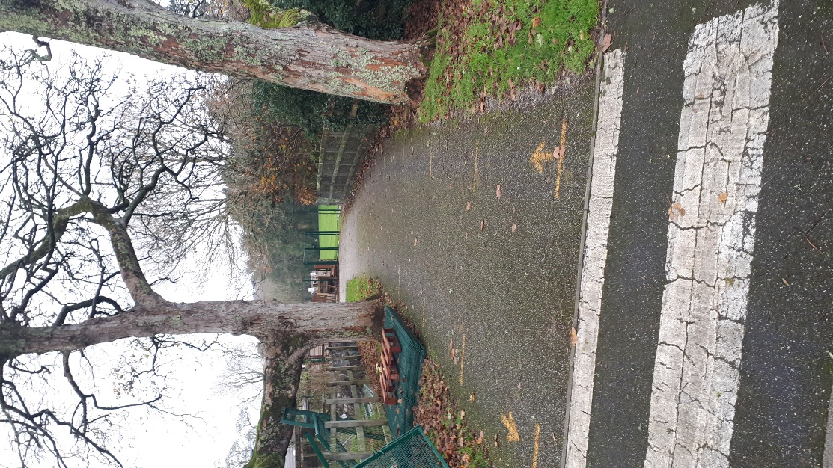
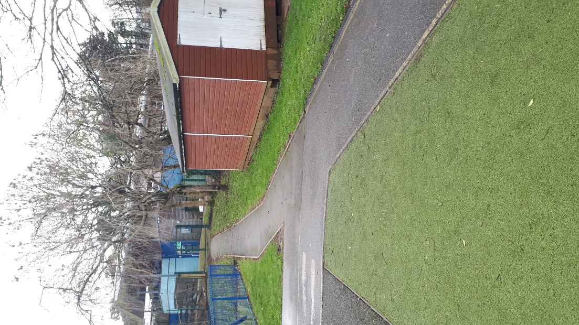

As you approach the rear gates the FCO (Ruth Carpenter) will instruct each class when to proceed to the allocated roll call points.
There are 2m separation lines on the floor leading from our rear gates up to the zebra crossing creating waiting bays.
Each class is to occupy 2 bays and leave 1 bay clear to assist in social distancing.
Palm, Elm, Juniper, Sycamore and Willow will assemble in these bays.

Acorns will assemble on the ramp leading up to the rear gates.

Maple class will assemble at the foot of the ramp.

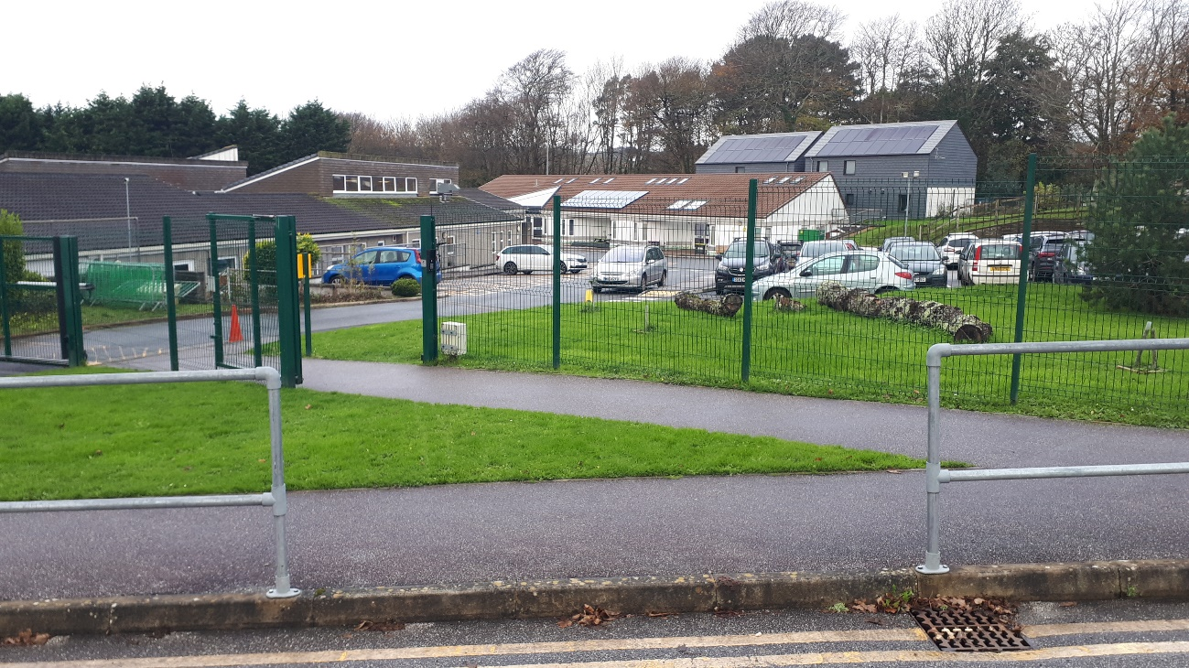
6th Form fire assembly point
Roll call protocol
Class lead to carry out roll call using classroom fire registers. All pupils, staff and visitors/ volunteers must be accounted for.
If all present and correct look for FCO’s visual signal.
FCO’s will raise 1 arm.
Each class lead must the show a raised arm to communicate that the register is complete and all are accounted for.
Once the FCO has acknowledged the visual signal from all class leads and is satisfied they will drop their arm. Class leads must wait for this visual signal before dropping their arm.

FIRE ALARM PANEL PROCEDURE
(Please note this is only a guide on using this specific panel).

- Collect fire alarm panel keys (located on a hook on the wall behind SH’s desk, spare set in GG’s office on key board).
- Attend panel and determine cause of alarm. (Read display on panel, a room/area number will be displayed- please refer to site map located on wall above the panel for confirmation).
- If safe to do so go to source of alarm and investigate (take keys with you if a call point has been pressed).
- If you are confident on false alarm, continue to point 5. If you are in any doubt begin emergency evacuation procedures (as listed in the School Fire procedure guide).
- Insert long black plastic key into underside of call point and rotate (the front plate of call point should pop back out into the ready position).
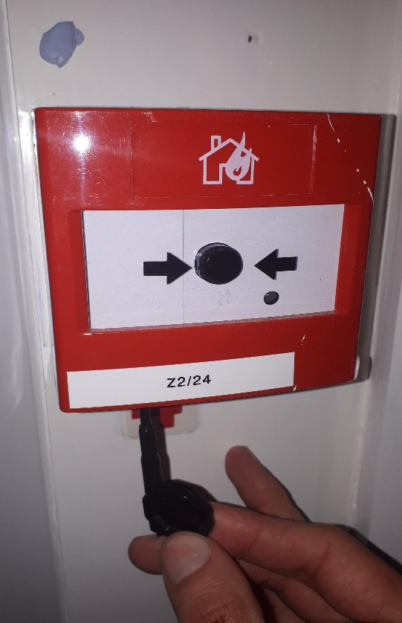

- Return to fire alarm panel.
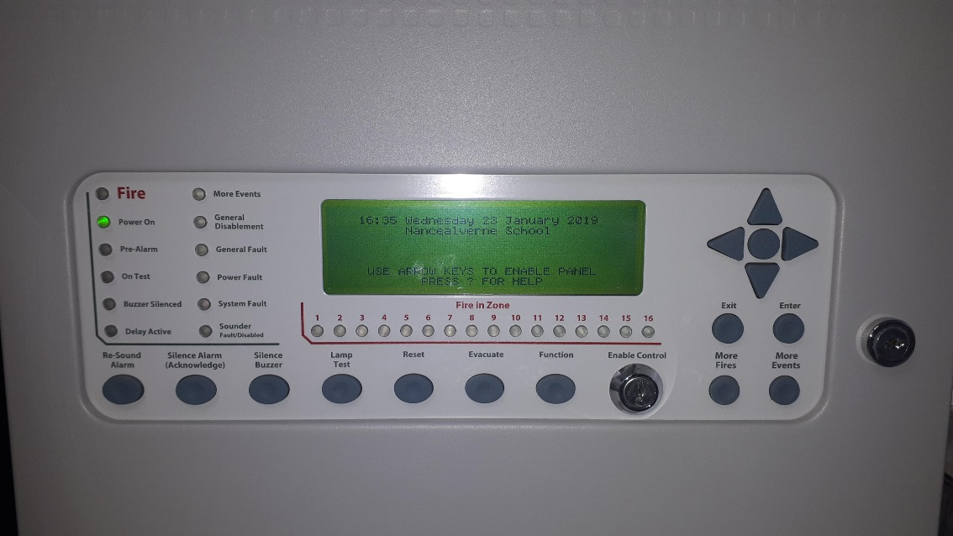
- Insert silver metal key into panel marked “enable control” then turn key.

- Press “silence alarm” (acknowledge).
9. Press “reset”

10. Remove keys and return to hook (as listed in point 1).
Revised January 2019 by GG

Office staff fire procedure protocol

- Evacuation Plan Overview (Fire Warden, SLT, & Office Team Duties) these are displayed around school.
- Registers printed from Arbour- Tyra will print at 9:45am then amend throughout the day for those students arriving late or leaving early due to bespoke timetables, illness or medical appointments. Registers are open between 9:10am – 9:40am in the morning and 1 – 1:40pm in the afternoon.
- Registers and Educational Visit forms of students that are off site will all go in the red wall file next to the office door.
- Emergency contact numbers for all students and staff are kept in the office cupboard in files but will need the office staff/SLT permission for access.
- All classes have their own fire registers, spare copies are also in the red wall file.
- The class teacher is responsible for completing this fire register in the event of a fire alarm and ensure this is taken out to the fire assembly point.
- Sarah takes out an iPad with the evacuation mode on it for all staff and visitors. Sarah will then tick off all staff and visitors either present/not present.

This is what you need to remember to take out with you
- Take out the daily attendance registers, fire registers and educational visits forms and walkie-talkies.
- iPad with evacuation mode
Revised sept 2022 – by T.B








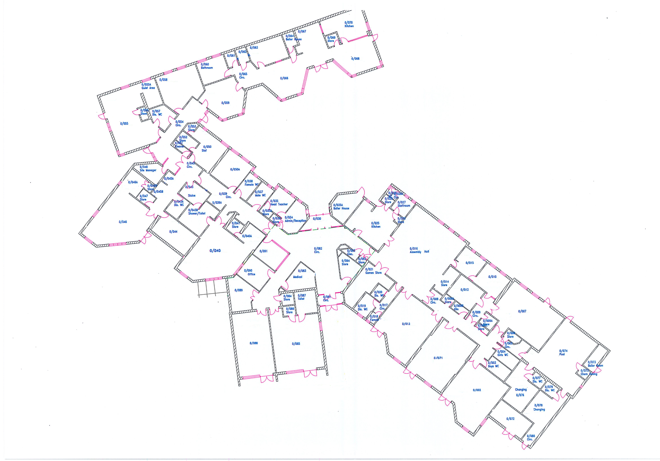
8
9
10
11
12
13
14
15
16
7
6
5
4
23
2
3
1
17
18
19
20
22
21
Main foyer [082]
Lower 6TH form
Class 6 [002]
Staff room
[055]
Class 7 [071]
Class 5 [040]
Upper 6TH form
Class 4 [013]
Class F [055]
Class 3 [085]
Class 2 [046]
PHYSIO[010]
The Hall [016]
Pool [074]
Nancealverne fire alarm call points
(Revised March 2019)

fire

THE FIRE TEAM    Ruth Carpenter- Fire Control and Assembly Officer  FIRE WARDENS      Pippa Pyrah  Gareth Gittins          Jamie  Woolcock  Caroline  Williams  Tyra Barnes  Sarah Hooper  A copy of Nancealverne School Fire Plan is available on request from the main office.  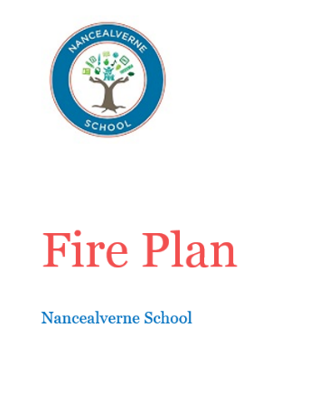 | Visitors  - Follow instructions from the Fire Control & Assembly Officer or the Fire Wardens.  - Evacuate the building using the nearest Fire Exit.  - Report to the fire assembly point (see map) and wait until a roll call has been made to ensure they have been accounted for.  - Remain at the fire assembly point until they have been told by the Fire Control & Assembly Officer or Fire Wardens that it is safe for them to leave.  - Parents/Carers MUST NOT remove their child from the custody of the class teacher without permission from the Fire Control & Assembly Officer.  All staff  - Must co-operate and comply with the arrangements and the duties required under the fire regulations.  - Must carry out any reasonable instructions from their manager in complying with the fire regulations.  - Understand their local fire instructions; how to raise an alarm and follow the instructions when evacuating the building.  - Be aware of any significant fire risks identified by the fire risk assessment.  - Must not interfere with or abuse any structural fire protection (i.e. wedging open designated fire doors) or interfere with any equipment provided for fire safety purposes.  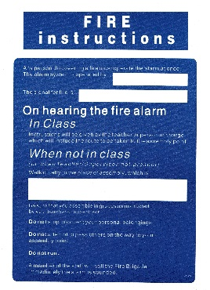  The school fire assembly point and fire instruction signs are placed at every fire point within the school building.  All areas have signage showing the nearest fire exit points.  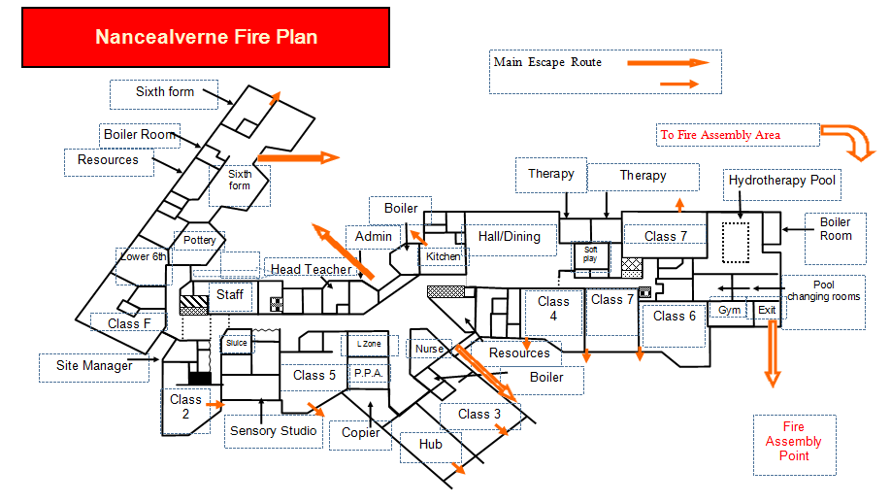    Fire Assembly Point  The Fire Assembly Point is located at the top of the drive adjacent to Pensans School Foundation Stage Entrance.  Please proceed calmly to the Fire Assembly Point ensuring that you use pavements and zebra crossing if exiting via the main entrance.  Access from the rear of the building is via the playgrounds following the path to the exit gate. | Fire  Procedure  Nancealverne School    In the event of a fire:  - Proceed calmly to nearest exit.  - Do not stop to collect belongings.  - Follow instructions given by the Fire Control & Assembly Officer and the Fire Wardens.  - Proceed to the Fire Assembly Point.  - Report to a Fire Warden /Officer.  - Remain at the Fire Assembly Point until instructed by the Fire Control & Assembly Officer that it is safe to leave the site &/or return to the building.  - Do not remove children from the supervision of school staff.  Action to take in the event of a fire  Discovery of a fire - if you discover a fire take the following action:  - Shout a verbal warning to others in the vicinity and immediately operate the nearest fire alarm point.  - The Office Staff will call 999.  - Inform a senior member of staff if possible.  - Proceed to your nearest exit and assist in the evacuation of the students. DO NOT collect belongings.  - The last person leaving any room should check nobody is still inside, turn out lights and shut the door.  - Evacuate the school and assemble well clear of the building at the assembly point.  On hearing the fire alarm  - The safety of the students is paramount. Proceed to your designated areas and assist in the evacuation of the students from the building by the nearest available exit - do not stop to collect personal items.  - Evacuate the school and assemble well clear of the building at the assembly point.  - Remain at the assembly area until you receive further instructions from the fire control and assembly officer.

PERSONAL EMERGENCY EVACUATION PLAN (PEEP)

Student / Staff
Name:

Buildings Covered by this plan:  Class __________ | Nancealverne School  Class :

ALARM SYSTEM:
I am informed of an emergency by: (tick all that apply)

Existing Alarm System |  | Any other notes or comments:
Visual Alarm System |  | Any other notes or comments:
Pager Device |  | Any other notes or comments:
My carer or buddy |  | Any other notes or comments:
Other: Please specify |  | Any other notes or comments:

DESIGNATED ASSISTANCE:
The following people have been designated to give assistance when I need to get out of a building:

Name(s) | Contact Phone Number
We have decided on a pre arranged meeting points for all locations: |  | YES | NO

EQIPMENT PROVIDED:
I need to use the following equipment: (please tick all that apply)

ResQmat |  | Any other notes or comments:  Training needed? Y/N
Mechanical Hoist |  | Any other notes or comments:  Training needed? Y/N
Vibrating Pager (Deaf Alerter System) |  | Any other notes or comments:  Training needed? Y/N
Other: Please specify below |  | Any other notes or comments:  Training needed? Y/N
None required |  | Any other notes or comments:  Training needed? Y/N

I need the equipment as listed above to be available in the following places:

CONFIRMATION OF USE OF EQUIPMENT : | YES | NO
The use of the equipment I need has been explained to my named staff
Other staff who know how to use the equipment are | Names:

EVACUATION PROCEDURE:
These are step by step instructions beginning from the sound of the first alarm:

1.
2.
3.
4.
5.
6.
7.

AWARENESS OF PROCEDURE:
The pupil is aware of / understands and has practiced with key staff the emergency evacuation procedures:
In a communication method that I use. |  | Any other notes or comments:

CONFIRMATION OF RECIEPT AND USE OF PEEP:
I understand that my parents, class staff, & other adults are responsible for keeping my PEEP as accurate as possible and drawing attention to changes in circumstance that should prompt a review.

The data provided by you on this form will only be available to Nancealverne staff, who may need to use it for the purpose of ensuring your health and safety whilst you are at School. It may also be shared with the emergency services if necessary. It will be stored in accordance to the Data Protection Policy.

My class teacher or contact for this is:

Signature of parent on behalf of Student : | Signature of Class Teacher
I understand the above notice and give my consent to my data being shared as detailed above.
Date: | Date:
Signature of School Business Manager H & S Lead | Date:

Copies in;
Class File
Office File
H & S Fire/ Evacuation file

