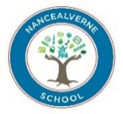

Nancealverne School SEN Information Report 2025-2026

This SEN information report offers key information based on the requirements set out in schedule 1 of the Special Educational Needs and Disabilities (SEND) Regulations 2014 and the SEND Code of Practice. The information contained within the SEN Information Report will be updated annually to reflect changes and development of provisions within our school. Further information regarding Nancealverne School’s offer can be found within the school’s policies and offer documents.

Our School
At Nancealverne School we are committed to and passionate about the learning and progress of our pupils. Staff and governors have high aspirations for our children and young people through a broad and varied curriculum; highly structured; differentiated and personalised learning programmes. We provide a specialist; high quality and relevant education for young people aged 3-19 who have moderate to complex learning difficulties. This focuses on individual, personal and academic achievement-setting high expectations for all.
Nancealverne School includes two main sites. Our Lower School site includes learners from Early Years and Foundation Stage (EYFS) through to Key Stage 4. Our Engaging to Learn groups (those learners with Profound and Multiple Learning Difficulties (PMLD)) are also supported at the Lower School. Our Upper School supports learners in Key Stage 4 and 5 and provides opportunities for these learners to experience a change of setting in a safe and supported way in preparation for adulthood and future transitions.
Nancealverne also includes a satellite provision - Cury School. Cury School is a Primary School provision specialising in supporting the needs of learners whose primary need is Social, Emotional or mental Health (SEMH) in nature.
As a school we are also committed to celebrating all achievements and providing a wide range of rich, meaningful and varied opportunities- preparing our pupils well for adulthood and life beyond school. We aim to foster a love of learning, regardless of need, developing independence through inclusive and accessible learning.
Our Trust
Nancealverne School is part of the Special Partnership Trust, an ambitious and inspiring collaboration of specialist provision in Cornwall, with a focus on excellence in learning for everyone. We are committed to ensure that every child, irrespective of need or location gets the best learning opportunities possible. We believe in providing challenge and support in equal measure to our pupils, nurturing the talents and skills of all learners.

- What are the kinds of special educational needs are provided for at Nancealverne School?

Nancealverne is a maintained special school for children aged 3 – 19 years. There are currently 138 pupils/students on role (September 2025); of these 120 attend Nancealverne School and 18 attend our satellite provision at Cury School. All children and young people (CYP) who attend Nancealverne will have an Education Health Care Plan (EHCP) in place, which indicates a Statement of Educational Needs. All children and young people will have identified needs in the area of ‘Cognition and Learning’ and may be described as having severe/profound and multiple or complex learning difficulties. In addition to a learning need, pupils may also have other associated needs in:

- Communication and Interaction Difficulties, (autistic spectrum disorders, speech and language difficulties)
- Physical Needs (e.g. mobility needs, physical disabilities, wheelchair users).
- Sensory or Medical Needs, (visual, hearing impairment, epilepsy, life limiting conditions etc.)
- Social/Emotional or Mental Health Needs (SEMH)

Pupils attending Cury School are aged between four and eleven years and will have SEMH identified as a primary area of need.

- What are the school's policies for the identification and assessment of the needs of pupils/students attending the school?

All pupils/students will have an Education Health and Care Plan (EHCP) in accordance to the code of practice. Within the EHCP the pupil/student’s primary ‘Area of Need’ will be identified along with any diagnoses of medical conditions, which may impact on their access to learning. Targets and provisions are included within the EHCP to ensure the pupils/student’s needs are met throughout their experience at Nancealverne School.

The ongoing assessment of the pupil/student’s needs are tracked through the use of Evidence for Learning, which allows us to create annual and twice yearly Personal Learning Goals (PLGs) that monitor progress. The following is an indicator of the ongoing and cyclical nature of the assessment of need process at Nancealverne School:

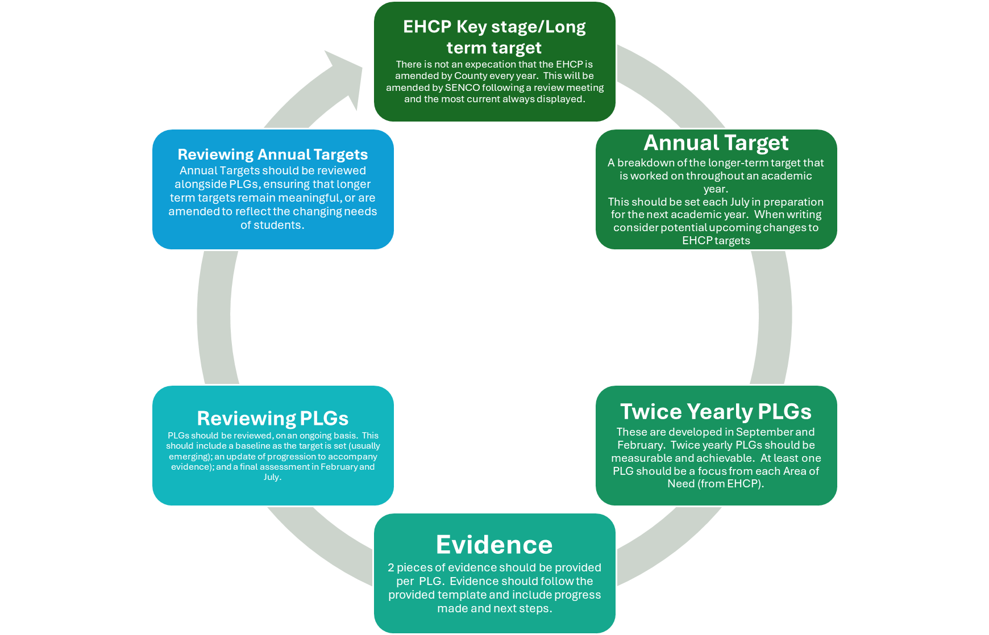

The school works closely with families, NHS therapy teams (including, Speech and Language Therapy, Educational Psychologists, Occupational Therapist and Physiotherapist) to ensure appropriate support is sourced as needs change.

In addition to support from therapeutic services provided by the NHS, as part of the ongoing process of assessing needs, Nancealverne School has also developed a Specialist Intervention approach that is able to offer further, support and intervention to inform and enhance the NHS offer. The following is an indicator of the Pathways approach to this assessment of individual needs:

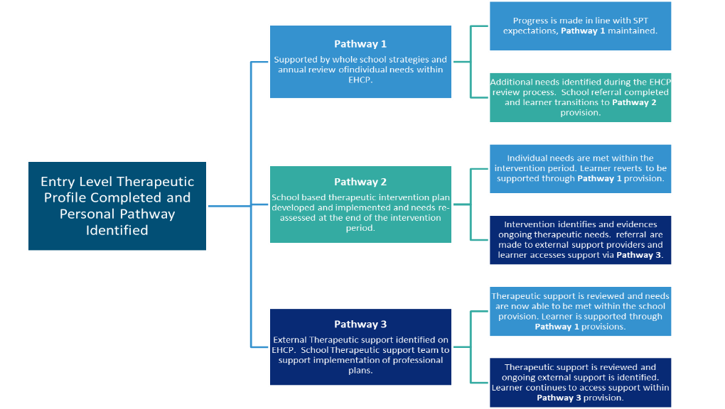

Further information regarding the identification and assessment of needs can be found within the school’s SEND Policy and can be found on our website.

Responsible Persons
The Head Teacher is Mrs Ruth Carpenter. Tel:01736 365039 rcarpenter@nancealverne.org.uk
The SENCO is Mr Andrew O’Neill. Tel: 01736 365039 aoneill@nancealverne.org.uk

- What arrangements are in place at Nancealverne School for consulting the parents of children with SEN and involving them in their child’s education?

At Nancealverne parents/carers are fully included in the process of working with their children/young adults; this is achieved through:
- Initial visits to school
- Introductory home visits
- A designated Family liaison officer
- Daily home/school book for information exchanges and key messages
- Use of class Dojo for ongoing communications
- Termly progress meetings to discuss progress including the design of short term targets
- An Annual review meeting of statement/EHC Plan, which includes a parent views collected prior to the meeting
- Parent workshops and training
- Coffee mornings
- Parental Representation on the Governing Body
- Parent involvement in changes in school through informal and formal consultations
- Whole School celebrations
- CIC/ePEP meetings for our children in care
- A list of contact details of support services for parents of pupils with SEN can be found on the school website.

- What are the arrangements for consulting young people at Nancealverne School and involving them in, their education?

At Nancealverne School consulting pupils/students and involving them in all aspects of their education and provision is central in ensuring personalised and child centred learning environment.

We recognise that an enhanced communication offer is central in consulting our learners to gain meaningful contributions that can involve them and impact on the educational offers they receive. A total communication approach supported by strategic communication systems and support, including, ‘The Hanging Out Program’ and ‘Specialist Intervention Team – Communication Pathways’, ensure that the voice of all pupils is shared and responded to.

Pupils are supported to develop their interests, curiosity and love of learning throughout all curriculum areas, and this is particularly evident within the PSHE curriculum and Personal Development offers, where the pupil’s voice and identity are nurtured, ensuring that they have the skills to share opinions and ideas (at an individual level) and that they have the knowledge that their ideas are valued.

We recognise the importance of utilising the pupils’ voice within the EHCP process, ensuring that all pupils are able to contribute to their review, through the most appropriate communication method and in turn adjusting outcomes and provision where appropriate to meet the pupil’s aspirations, by building on perceived strengths and interests. Pupil contributions can be collected through, pupil view/my view documents, PowerPoint presentation contributions, or through the skilled support of staff able to interpret pupils needs through careful observation and relationship building.

The School Parliament further develops the pupil voice and involves students taking on mentor roles and advocating for learners across the school. Parliament members take part in planning key events throughout the school year and produce regular newsletters featuring information that is important to them.

Pupils/students have an opportunity to share their daily views and experiences within the home/school diaries, where they are supported to complete sections linked to feelings and favourite aspect of the day.

- At Nancealverne School what are the arrangements for assessing and reviewing pupil/students’ progress towards outcomes?

At Nancealverne School we want every child and young person to make outstanding progress, we have high expectations for all our young people, and we strive towards pupils achieving good progress towards their individual goals.
Progression is estimated and measured based on a number of factors including individual needs, comparative data collected across the SPT, use of the Engagement Model and accreditation pathways using Ed Excel Functional Skills for Maths and English, which link to destinations requirements. Progression is also tracked using tools generated through Connecting Steps that utilise historic information within the Progression Guidance produced by the Government.
At Nancealverne pupils/students are assessed and supported within one of four curriculum pathways: Engagement, Exploration, Discovery and Investigation.
Curriculum data is tracked using BSquared/Connecting Steps and includes Learning outcomes based on Progression Steps (for Exploration, Discovery and Investigation pathways) and Engagement Steps/Routes for Learning (for our Learning accessing the Engagement pathway).
'Evidence for Learning' is used to collect evidence and track progress towards a pupil/student’s Area of need targets as outlined within their Education Health and Care Plans. These outcomes are used to inform Personal Learning Goals (PLGs) to ensure an ongoing and rigorous assessment process is in place to support these key outcomes.
Assessment/Pupil Progress meetings are held termly, to support the tracking of progress, ensuring measuring the impact of assessment is both robust and meaningful for all.
Pupils/students are involved in the assessment process throughout. Pupils/students are supported to evaluate their own work on an ongoing basis and are given regular opportunities to undertake peer assessment. PLGs are presented in language appropriate to the needs of the learners and they are supported to understand purpose, intent and expectations of these targets. Pupils and Learners are supported to complete pupil view section of their annual review of the EHCP and within this document are able to share successes and areas for development.
Young people in Key Stage 4 and the Post 16 work towards achieving externally accredited awards from Ed Excel and ASDAN. The progression of students in Key Stage 4 and 5 is assessed against adult functional skills outcomes within BSquared’s Steps 4 Life framework alongside functional skills acreditations. This allows for tracking from pre-entry levels (Steps 1-7), within entry levels 1-2 and on to level 2. Throughout the modules within Key stage 4 and 5 students evaluate their work against the agreed assessment criteria.
- What are the school’s arrangements for supporting pupils/students in transferring between phases of education or in preparing for adulthood?

At Nancealverne School we provide a structured and planned approach in supporting pupil/students transferring between all phases of education. Key arrangements are made during the following transitions and are outlined below: starting school, internal transitions between classes and key stages, transitioning to external educational providers.

Starting School

Transitions between classes and key stages

Transitioning to external educational providers

- At Nancealverne what approaches/adaptions to the curriculum are used for teaching pupils with SEN?

At Nancealverne School we believe in maximising every opportunity to support meaningful and purposeful learning to meet the needs of our learners; setting high expectations and challenge to achieve the best possible outcomes.

To achieve at Nancealverne School there is an extensive curriculum offer, which is available on the school website. Our curriculum is designed to ensure our learners achieve their full potential, are able to communicate their needs, knowledge, choices and aspirations and enjoy their school experience. We value each learner highly as individuals and aim to personalise all their learning experiences as much as possible. We do this by using both their EHCPs and the National curriculum, which is adapted as necessary to enable the learners to access it, whatever their needs.

Our learners broadly follow four different curriculum pathways: Engagement (our learners working within the engagement model, including those with PMLD); Exploration (our pupils who, in addition to their primary needs may have complex communication sensory or social and emotional needs); Discovery: (our pupils able to follow a structured subject specific curriculum offer with the specialist universally offered adaptations); Investigate: (our pupils able to follow a structured subject specific curriculum offer with the specialist universally offered adaptations and making progress towards a more formal qualification and employment pathway). In addition to these four pathways, the school offers specialised provisions for Early Years, KS4 and Post 16, enhancing opportunities to develop the skills and knowledge needed during these key transitional stages. Provisions are also made for bespoke individual learning needs.
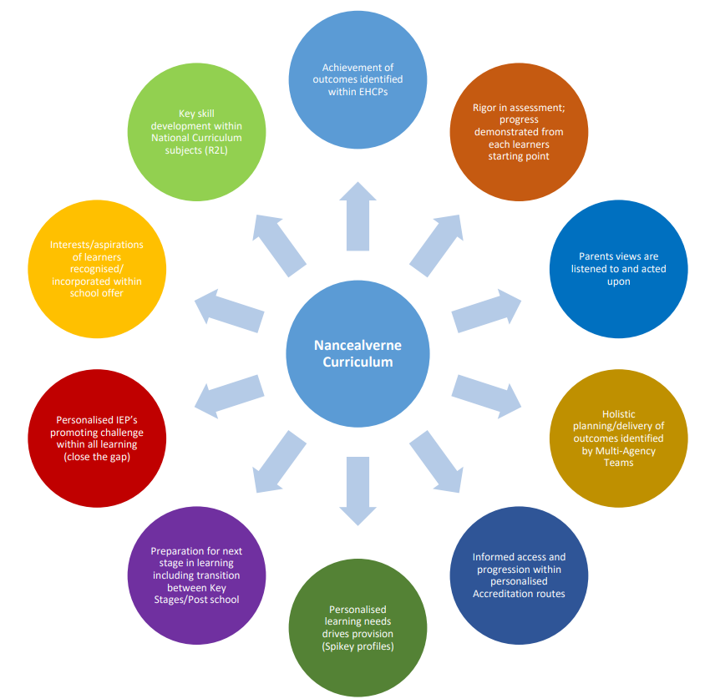

Details of the teaching strategies and curriculum strategies for these groups can be found within the school’s curriculum offer.

In addition to the specialised curriculum development, the staff employ wide and specialist teaching approaches including, but not restricted to:
- Total communication strategies
- Symbols based communication systems, including picture exchange (PECS)
- AAC use, including high tech and low tech communication aids, alongside modelling
- Makaton/BSL
- On the body signs
- Visual/verbal reinforcement
- Intensive interaction
- TEACCH
- Attention Autism
- Sensory Engagement Regulation profiling

- At Nancealverne what adaptions are made to the learning environment for pupils with SEN?

At Nancealverne School, creating and inclusive community is at the heart of our school’s ethos. Central in this is providing a learning environment that is accessible to all. To achieve this the Nancealverne has developed core environmental offers that ensure the pupil/students needs are met across the four key areas of need: Communication and interaction; Cognition and Learning; Social, Emotional and Mental Health; and Physical and Sensory. The following is an indication of the adaptions and considerations that are in place to meet needs in each area:

(Whole School) Environmental and Resourcing Offer
Cognition and Learning / Communication and Interaction
Pathway 1 | At Nancealverne we offer and environment that benefits from:  - Total communication approach, which includes:  - Non-verbal/pre-verbal strategies, including auditory, visual, and physical/textural cue to support and reinforce routines, environmental changes and understanding of the world  - Visual aids in place throughout the school to support environmental understanding including, objects of reference, photographs and symbols  - Consistent use of PCS symbols throughout all learning environments through to Key Stage 4 (An introduction to Widgit symbols at this stage, to support transition to, extend symbols knowledge in line with those readily available in the community)  - The use of Makaton signing alongside speech to introduce vocabulary  - Visual timetables available in all classes  - Low tech communication resources available in all classes including: Core Boards and PECS systems.  - Transition aids available, including objects of reference, photos, words and symbols  - Playground communication core-boards  - Traffic lights and core vocabulary symbols attached to all members of staff  - AAC devices available including: big macs, switches, Go Talks, Proloquo, Clicker, Widget and Boardmaker
Pathway 2 | At Pathway 2 in addition to the whole school environmental provisions we also offer:  - Therapy/Intervention spaces within school environment  Development of bespoke environmental communication aids
Pathway 3 | At Pathway 3 in addition to the provisions made within Pathways 1 and 2, we also offer:  - Therapy/Intervention spaces within school environment  Development of bespoke environmental communication aids for use at school and at home

(Whole School) Environmental and Resourcing Offer
Social, Emotional and Mental Health / Sensory and Physical
Pathway 1 | At Nancealverne we offer and environment that benefits from:  - Total communication approach, which includes:  - Non-verbal/pre-verbal strategies, including auditory, visual, and physical/textural cue to support and reinforce routines, environmental changes and understanding of the world  - Visual aids in place throughout the school to support environmental understanding including, objects of reference, photographs and symbols  - Consistent use of PCS symbols throughout all learning environments through to Key Stage 4 (An introduction to Widgit symbols at this stage, to support transition to, extend symbols knowledge in line with those readily available in the community)  - The use of Makaton signing alongside speech to introduce vocabulary  - Visual timetables available in all classes  - Transition aids available, including objects of reference, photos, words and symbols  - Playground communication core-boards  - Traffic lights and core vocabulary symbols attached to all members of staff  - Hydrotherapy pool  - Sensory room timetabled for all learners  - Soft Play room timetabled for all learners  - Sensory Garden  - Physical based playground equipment  - School Gym  - TacPac resources  - Sensory regulation resources including:  - Weighted blankets  - Exercise/peanut balls  - Seating  - Fidget toys  - Breakout spaces identified throughout the school  - Trampoline for rebound therapy  - Hoists and slings  - Changing beds  - Mats, including evacumats  - Moving and Handling passports, including PEEPs  - School nurse  - A range of adapted cutlery and plates
Pathway 2 | At Pathway 2 in addition to the whole school environmental provisions we also offer:  - Therapy/Intervention spaces within school environment  - Development of bespoke sensory regulation resources
Pathway 3 | At Pathway 3 in addition to the provisions made within Pathways 1 and 2, we also offer:  - Therapy/Intervention spaces within school environment  - Development of bespoke environmental communication aids for use at school and at home  - Individual needs equipment sourced through the NHS team including:  - Wheelchair services  - Hoist/sling assessments  - Standing/walking frames  - Adaptive footwear  - Adaptive splints  - Acheeva Beds  - Medicare care equipment e.g. gastro electric vacuum pumps

- At Nancealverne how is the training and expertise of staff ensured to meet the needs of pupils/students

At Nancealverne School we recognise that a skilled and impassioned staff team is the single most important resource in achieving our ethos and aims for our pupils/students. In order to ensure this the following considerations and strategic structural models are in place:

Leadership
The school’s Leadership consists of a skilled and experienced team, that is enhance by the networking approach adopted across the Special Partnership Trust. This ensures that strategic planning is developed and scrutinised by a multi-skilled and multi-professional group, which includes governors and therapy providers.

The school’s performance management and professional development process ensures a staff team that strives for theory driven, personal development in aspects that meet the changing needs of our pupils/students. In addition to performance management the Leadership team and middle leaders provide line management to teaching staff, ensuring that individual training needs are identified and met.

Senior leaders ensure that staffing levels are enhanced to ensure that pupils are taught in classes where their individual levels of needs can be effectively met. Classes will therefore consist of up to ten with a teacher and a minimum of three teaching assistants to meet the needs of the class group. Staffing levels are determined by each pupil’s band of need that has been established by the Local Authority.

Training
A carefully planned training programme is in place to ensure key training needs; including statutory requirements are met on an ongoing basis. Specialist ongoing training includes:
- Team Teach
- Epilepsy Training
- Medication Administration Training
- Safeguarding
- Moving and Handling
- Individualised physiotherapy programs and strategies
- Makaton
- Sensory processing

External Professional Guidance
The school receives advice from a range of health professionals in order to meet the needs of the pupils as assessed by the appropriate professionals involved. Nancealverne works closely with our health and social care colleagues to implement the revised SEN Code of Practice. We work closely with families and our learners to discuss/agree long-term outcomes to inform the EHC Plan, monitoring the implementation of these throughout the school year.

In addition to this as part of our pathway two specialist intervention strategy in additional to the NHS therapeutic/health professional input, support is sourced from skilled professional agencies, ensuring the most up to date theory and strategies is shared with the school team.

- At Nancealverne what provisions are in place to support the emotional and social development of pupils/students with SEN?

At Nancealverne School we recognise the importance of promoting and supporting the emotional and social development of our pupils/students. A range of considerations are embedded within the schools practice to ensure these needs are met:
- The social, emotional and mental health of our pupils/students is a key area of need outlined within each EHCP. This ensures all learners have long term, annual and termly targets to support their development in this area. Progress towards these outcomes are assessed within Evidence for Learning.
- The PSHE curriculum offer provides clear pathways for the development of emotional and social development. The assessment of PSHE offers a further tools for tracking the social and emotional development of pupils/students throughout their Nancealverne journey.
- Nancealverne is a Trauma Informed School (TIS) and is able to offer both an embedded approach to support pupils/student’s needs across the whole school day and a targeted TIS intervention pathway, informed by Motional Assessments to support pupils/students additional SEMH needs.
- Pupils/students at Nancealverne will receive a Sensory, Emotional Regulation Passport, ensuring that resourcing and strategies are available to support in developing emotional regulation and personal strategies for managing these needs.

- At Nancealverne how is equipment and facilities secured to meet the needs of pupils/students with SEN?

The provision of appropriate equipment and facilities is essential in meeting the needs and ensuring the safety of the pupils/students at Nancealverne. The individual provisions for the pupils/students are outlined within their EHCPs. Provision requirements are updated as part of the Annual Review of the EHCP process. As the amendments to provisions are finalised the process for securing facilities/equipment will be dependent on the nature of the provision needed:
- Most educational equipment identified will be ordered by the SENCO and agreed by senior management.
- Physiotherapy equipment will be assessed and ordered by NHS providers (usually through Medequip). Further details are available in the SPT Moving and Handling Policy.
- Equipment linked to moving and handling will be assessed and ordered through NHS/Community OT/Physiotherapy services (usually supplied and maintained by Community OT/Medequip). Further details are available in the SPT Moving and Handling Policy.
- Specialist AAC equipment is organised through a referral to Speech and Language for an ongoing referral to the CACAAT or AAC West teams.

- At Nancealverne how is the effectiveness of the provision for pupils/students with SEN evaluated?

The effectiveness of the provision at Nancealverne school is measured using a variety of methods, including through OFSTED inspections. During the last inspection ‘Outstanding’ provision was identified and recommendation was made for a full inspection to further confirm this judgement. The school undergoes termly School Improvement Partner (SIP) visits to ensure that standards are upheld and improved between OFSTED cycles. In addition to the SIP visits the school also takes part in a peer review process, whereby senior practitioners from across the trust schools complete annual peer evaluations of each school. The school also has a robust governing body able to provide challenge as part of an ongoing process.

- How are other bodies - including health, social services, local authority services and voluntary organisations, involved in meeting the needs of pupils/students at Nancealverne and in supporting their families?

Nancealverne School has a wide range of staff working together within the school to support the children, young people and their families. Some are employed directly by the School, others have different lines of management.

Classroom staff are employed directly by the Special Partnership Trust. This includes teachers, teaching assistants and lunchtime supervisors. Administration staff are also school employees.

The School accesses specialist advice and support from providers including, the Community Training Team, Speech and Language Therapists, Dietitians, Occupational Therapists and Physiotherapists; these are employees of Cornwall’s Health providers; all such professionals who work within school offer training for staff, advising them on their work with children and young people. The school meets on a regular basis with social care and health care managers to ensure relevant information, national guidance in relation to health/well-being is discussed/cascaded in an informed way.

The Visual/Hearing Impairment advisory teachers and Educational Psychologists are employed by the Local Authority; they provide staff training and advice on individual children's needs in accordance to their core/statutory offer.

Transport to school is organized by the Local Authority not the school. Transport staff are employed by the transport companies; transport is requested by the school who outline pupil need via the Transport Request Form (TRF) outlining risk assessments which may be required.

There are social workers for children/young people with disabilities who are Local Authority Employees and are based within the Children/Adult Specialist Services. The school meets on a regular basis with social care managers to ensure relevant information, national guidance in relation to social care is discussed/cascaded in an informed way.

If you have a query relating to any of these areas it is best to contact the professionals directly. This will ensure that your message/queries/concerns are dealt with in the most efficient way; the school is able to provide contact details for social care/health colleagues.

- What are the arrangements made by the Local Governing body for dealing with complaints from parents/carers of pupils/students in relation to the provision at Nancealverne School?

The process for all complaints is made available via our school website; this policy is updated each year.

- What are parents able to contact if they have concerns?

In case of concerns, parents are able to contact any of the following:
- The Head Teacher is Mrs Ruth Carpenter. Tel:01736 365039 rcarpenter@nancealverne.org.uk
- The SENCO is Mr Andrew O’Neill. Tel: 01736 365039 aoneill@nancealverne.org.uk
- The Home/School Liaisons are Beth Jones and Stephanie Holmes. Tel: 01736 365039 bjones@nancealverne.org.uk and sholmes@nancealverne.org.uk
- Chair of Governors is Ms Alison Bone. abone@nancealverne.org.uk
- The Director of the SPT is Mr Guy Chappell. info@specialpartnership.org

- Where is the information on the Local Authority local offer published?

There is further detail on our website on our own school offer for SEND and this links to the Local Offer on the Cornwall Council website.

