Nancealverne School Curriculum Overview 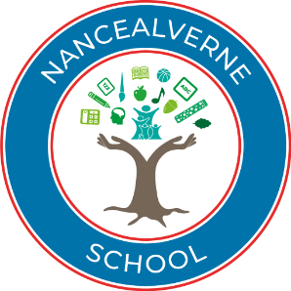
2023-26

Nancealverne Values

“Achieving high academic outcomes, celebrating achievements, and providing a wide range of
rich, meaningful, and varied opportunities for all children; preparing them well for adulthood and life beyond school.”

- Healthy: To foster caring and trusting relationships between pupils and staff: celebrating individual achievements, respecting pupils as individuals who have the potential to learn and make a unique contribution.

- Achieving: To develop a broad and varied curriculum through the dynamic teaching, highly structured, differentiated, and personalised learning programmes- setting high expectations.

- Positive contribution: To foster a love of learning in all our pupils, regardless of need; to develop independence and self-confidence preparing them well for adulthood and life beyond school. To be a strong presence and make a meaningful contribution to our local community, developing the role of the school as part of the total education provision in Cornwall.

Our School Structure
We have chosen to structure our school as follows:
Lower School
 | EYFS/ KS1/KS2 | Class Base | Learning Phase | Rationale Considered
Early Years Foundation Stage | EYFS/ KS1/KS2 | Acorns | Nursery 1  Nursery 2  Reception  May also feature Yr1 | An EYFS class that follows the EYFS curriculum and ethos. Pupils are assessed using Evidence for Learning and Cherry Garden.  Learning through play is an important part of pupils' educational experience at this stage, giving children the opportunity to explore and discover and build on their skills and interests. Children work towards 'Early Learning Goals' which help develop the skills they will need as they grow older and move on to the National Curriculum.  Learning is organised through child-initiated learning, tabletop and sensory activities, structured group, adult directed learning, small group, pairs, 1:1 supported, child-led, therapeutic intervention in class or in a bespoke therapeutic space following personalised programmes from a therapist. Ther is also participation in whole school and early-stage community-based activities. Learning takes place both in the indoor and outdoor learning environment.
Infants and Juniors | EYFS/ KS1/KS2 | Sycamore  Chestnuts | Year 2/3/4  Year 2/3/4 | A holistic, play based environment as pupils move towards more subject specific learning. Pupils have access to an appropriately differentiated National Curriculum. A wide range of teaching and learning strategies are used throughout the school to deliver this effectively.  Pupils between the ages of 5 – 16 have access to an appropriately differentiated National Curriculum. A wide range of teaching and learning strategies are used throughout the school in order to deliver it effectively. Some pupils are able to access the curriculum following a multi-sensory approach specific curricular activities include hydrotherapy, massage, sensory communication, and ICT. Our sensory offer includes a high level of interactive equipment, and every effort is made to ensure that work is age appropriate. Work is comprehensively differentiated.  As well as the subject specific National Curriculum subject areas, other enrichment activities form an important part of the school day – these may include physiotherapy, speech and language therapy, self-help skills, drama and music workshops, rebound therapy, day and residential visits, whole school collective worship, community and sporting activities, events such as Sports Days, riding and swimming, visits to local schools, colleges, churches, museums and art galleries.
Infants and Juniors | EYFS/ KS1/KS2 | Juniper  Palm | Year 4/5/6  Year 5/6/7 (KS2/3 Class) | Primary aged class with subject specific learning. We offer a broad and varied curriculum; highly structured; differentiated and personalised learning programmes. We provide a specialist; high quality and relevant education for all pupils.
Upper School
Secondary | KS3 | Elm | Years 7/8/9/10 | A secondary class with subject specific learning. We offer a broad and varied curriculum; highly structured; differentiated and personalised learning programmes. We provide a specialist; high quality and relevant education for all pupils.
 |  | Willows | Years 7/8/9/10 | Willow Class is a specialist pupil led provision which operates within a burst/pause structure, designed to lower the children’s anxiety, meet their individual sensory and communication needs and encourage independence of learning. The curriculum is a combination of formal learning in the core areas of English, Maths, PSHE and PE and the areas of the Access and Enrichment Curriculum.  The aim of the Semi-Formal Curriculum is to provide a functional and effective learning experience to children and young people identified as meeting the “Bridging to Learn” criteria. Willow Class is a pupil led provision which operates within a burst/pause structure, designed to lower the children’s anxiety, meet their individual sensory and communication needs and encourage ownership of learning. The curriculum is a combination of formal learning in the core areas of English, Maths, PSHE and PE and the areas of the Semi-Formal Curriculum. The main aims of the Bridging to Learn provision are to:  - Develop functional literacy and numeracy skills, relevant to each individual’s level of understanding  - Provide context about the world around them  - Establish independence in all areas of the pupils’ lives  - Increase the children’s ability to focus on tasks individually, and as part of a group  - Increase attention and response  - Develop the children’s working memory, knowledge retention and recall  - Develop communication by providing a “Communication Toolbox” which focuses on imperative and declarative communication  - Encourage engagement and participation, either coactively or independently  - Provide the opportunity for supporting adults to model positive communication skills, such as listening, eye contact, responding, reciprocity and respecting others’ opinions
 | KS1/2/3/4/5 | Maple | Multi-year | A specialist multi-sensory class and environment for students with Profound and Multiple Learning Difficulties (PMLD). A full access and enrichment curriculum is offered.  These learning experiences may be provided in a variety of formats – individual, paired, small group and whole group. However, we recognise the individual needs, personalised learning plans and talents of each learner which facilitates development of their intellectual, moral, physical, social, and creative capacities. Therefore, each pupil has a personalised learning to learn profile, which includes objectives and targets set taking information from variety of sources including:  - Developmental stage of the learner/ Engagement model of learning  - EHC Plans  - Reports and information from multi-agency teams and involved professionals (including therapy plans and advice/guidance)  - Information gained from parents/carers  - Levels of support/resources required to access/engage in purposeful learning  The above is offered by a highly skilled and specialist team of teachers and teaching assistants, working with external agencies and multi-professional teams to ensure the best outcomes for our pupils.
Secondary/ Post-16 | KS4/5 | Lower Evergreens | Years 10/11/12 | From Key Stage 4, pupils follow a transition course which leads to accreditation and qualifications where appropriate. The expectation is that the majority of learners leave Nancealverne school with a Qualification in ASDAN Personal Progress or Personal and Social Development at Entry Level, as well as accredited learning in other areas of ASDAN. For those students who are able to, we also offer functional skills qualifications in English and Maths through Edexel. ASDAN modules focus on skills including communication, numeracy, literacy and PSHE (Personal, Health and Social Education) as well as life skills which aim to develop individual personal autonomy and independence. The qualifications and accreditations are nationally recognised by the awarding bodies and demonstrates recognition of the students' achievements. Students also work towards achieving the Duke Of Edinburgh Award.
Post 16 | KS5 | Upper Evergreens | Years 11/12/13/14 | The students are encouraged to be as independent as possible and to be aware that their actions have implications not only for themselves and for others. During the year students will participate in focus weeks when the modules they undertake will work towards enterprise, industry, and work-related skills. These modules help to demonstrate to the students their roles and responsibilities as part of the wider community of which they are an important and integral part.  The school forms strong relationships with parents, Social Care and Careers South West to select and access post-school opportunities. A careers convention is organised annually where all providers are invited to the school. A link course is offered at the local college and students are encouraged to look at alternative placements from the age of sixteen. Visits to post 19 provisions are regular throughout the school year, and learners are encouraged to make choices about their future with the support of their family, the school and independent careers education and advice. There are many local colleges and establishments offering suitable courses and placements for post 19. Students are given supported induction and transition to these different settings in their last year at the school.

What we aim to achieve?  Curriculum INTENT |  | Nancealverne  Curriculum  Achievement of  outcomes identified  within EHCPs  Rigor in assessment;  progress  demonstrated from  each learners  starting point  Parents views are  listened to and acted  upon  Holistic  planning/delivery of  outcomes identified  by Multi  -  Agency  Teams  Informed access and  progression within  personalised  Accreditation routes  Specialist Intervention Team- Referral route for individual support  Preparation for next  stage in learning  including transition  between Key  Stages/Post school  Personalised PLG’s  promoting challenge  within all learning  (  close the gap  )  Interests/aspirations  of learners  recognised/  incorporated within  school offer  Key skill  development within  National Curriculum  subjects (R2L)
Curriculum INTENT |  | Whilst we follow the objectives of a structured subject- specific curriculum, we offer highly- differentiated and personalised learning programmes. We deliver a specialist, high-quality and relevant education. This focuses on personal skills and academic achievement, setting high expectations for all. We appreciate that students may not be working at age related of key-stage expectations and therefore measure progress from individual starting points.  - Leaders construct a curriculum that is ambitious and designed to give all our learners, particularly the most disadvantaged, and that have special educational needs and/or disabilities (SEND) or high needs, the knowledge and cultural capital they need to succeed in life.  - To provide an outstanding broad and balanced education, which is personalised to the individual needs of each pupil.  - To provide a curriculum that is coherently planned and sequenced towards cumulatively sufficient knowledge and skills for future learning and employment.  - Through the identification of the appropriate curriculum pathways, we secure outstanding outcomes in developing pupil’s academic achievement, independence, engagement, and social skills.  - To provide a calm, learning focused environment, which is safe, caring and nurturing.  - To develop and maintain strong and mutually supportive relationships with parents and carers.  - To provide a holistic education, which incorporates guidance and strategies from support agency partnerships e.g., speech and language therapists, occupational therapists, physiotherapists etc.  - Remains as broad and balanced as possible for as long as possible, including when delivered remotely.  - To increase resilience and develop pupils’ ability to self-regulate.  - To develop pupils’ essential life skills, developing their knowledge and the cultural capital they need to succeed in life (personal development).  - To promote physical and emotional well-being for all learners.  - To provide informed access and progression within personalised Accreditation routes.  - To prepare pupils for the next stage of their education.  - To ensure all pupils have a genuine ‘voice’ and opportunity of choice.  - To ensure all pupils leave Nancealverne with outcomes that reflect the best of their ability.  - To ensure the best possible long-term outcomes are available for all pupils.  - To ensure Nancealverne values are at the heart of learning.
Curriculum IMPLEMENTATION  How do we organise learning at Nancealverne? |  | - There are three main learning groups within the school: Severe Learning Difficulties (SLD), Autistic Spectrum Disorder (ASD) and Multi-needs (PMLD).  - Within these groups we have three learning pathways, identified as Ready to Learn (R2L), Bridging to Learn (B2L) and Learning to Learn (L2L).  - Fundamental to any personalised learning pathway is the schools’ response to outcomes identified via Education, Health and Care Plans (EHCP) which are fully implemented in any one of the pathways being pursued.  - Our learners broadly follow three different curriculum pathways:  - EHCP outcomes identified through the Annual Review process are addressed/assessed throughout the academic year. Targets identified enable learners to work towards longer term aims ensuring development of key skills which secures progress over time within the areas specified. EHCP outcomes are addressed within all personalised learning routes regardless of pathway taken.  - All pupils have full access to a broad and balanced curriculum which is differentiated to meet pupils’ learning needs and styles.  - Our curriculum is designed to be challenging and appropriate to the pupil’s stage of development.  - Preparation for next stage in learning including transition between Key Stages/Pre-/ Post-school. The school recognises the importance of effective transition; through assessing pupils holistically, using a range of assessment frameworks, the school can identify personalised learning needs, achievements (progress) and next steps for learning.  - The school ensures that accreditation is meaningful and clearly reflects the skills and understanding which students need to develop. It is imperative that accreditation provides value in the work that students have pursued through their bespoke curriculum/personalised learning route and all accreditation strengthens learning.  - Our curriculum offers significant cross-curricula learning opportunities to ensure pupils make significant personal development.  - Our core subjects are English, Maths, PSHE, Physical Development and Science.  - We have a strong focus on Physical Education and Physical Development. We offer a full Physical development programme including Rebound Therapy, Move and Real PE programmes.  - Our curriculum covers a wide range of core and foundation subjects. We dedicate substantial time to both.  - Our curriculum is designed to build and expand on previous skills and subject knowledge.  - We offer a wide range of qualifications, which are selected to appropriately challenge, based on the pupil’s stage of development.
  - Learning to learn Our pre-formal learning pathway
  - Bridging to learn: Our semi-formal learning pathway
  - Ready to learn: Our formal learning pathway.
- Nancealverne recognises the importance of ensuring long terms curriculum aims develop pupil’s interests and aspirations. We consider it vital that the voice of all learners is recognised and is, importantly, acted upon. As part of the Careers and Work-Related Learning curriculum and at Annual Reviews, each learner is provided with key information identifying how the curriculum will support their aspirations.
- By building respectful relationships with parents/ carers, the school secures effective partnerships. Through Annual Review and termly pupil progress meetings the school elicits the views of parents/ carers determining how such views can enhance educational opportunities. Termly reports to parents/ carers evidence pupil progress over time in relation to bespoke personalised curriculum /learning pathway.
- The school works closely with Multi-Agency Teams incorporating advice and recommendations received from them into the pupil’s school day (e.g. – well-being/therapy plans). To secure effectiveness the school monitors progress (where appropriate) within such plans; through our bespoke provision the school is able to address these through IEP’s (e.g. – communication targets) or within structured teaching/learning sessions (e.g. – music therapy).
- Enjoyment and engagement in learning is incredibly important to us, we therefore also run regular whole school theme days throughout the academic year.
- At Nancealverne we work in a Total Communication environment. This means that we work on key principles of communication which involves the use of symbols, pictures, PECS, Makaton Key Word signing and communication passports. We use low tech and high tech AAC methods. We have a dedicated group of 'communication champions' whose job it is to develop different resources for classes to adapt to their children. All staff wear portable communication aids/ visuals to support all learners.
Teaching and Learning
- All classes are led by qualified and experienced education professionals.
- All staff have additional training on supporting learners with Special Educational Needs. This is personalised to the particular needs of the learners.
- All staff have good knowledge of the subject(s) and courses they teach. Leaders provide effective support, including for those teaching outside their main areas of expertise. All staff are supported by experienced subject leads.
- All staff check learners’ understanding systematically, identify misconceptions accurately and provide clear, direct feedback. In doing so, they respond and adapt their teaching as necessary.
- All staff deliver the subject curriculum in a way that allows (as possible) pupils to transfer key knowledge to long term memory. Teaching is sequenced so that new knowledge and skills build on prior learning and pupils can work towards clearly defined outcomes.
- A rigorous approach to the teaching of reading develops learners’ confidence and enjoyment in reading. At the early stages of learning to read, reading materials are closely matched to learners’ phonics knowledge.
- There is a full Continuous Professional Development (CPD) available for all staff. This includes access to and completion of National Professional Qualifications (NPQs).
- Quality of teaching is observed and reviewed by Subject Leads (Middle Leaders) and Senior Leaders. There is also an external moderation of teaching schedule.

Assessment |  | Assessment  - Teachers and leaders use assessment well, for example to help learners embed and use knowledge fluently or to check understanding and inform teaching. Leaders understand the limitations of assessment and do not use it in a way that creates unnecessary burdens for staff or learners.  - Nancealverne uses rigorous assessment system Evidence for Learning to collate progress evidence towards individual personal learning goals. We also continue to use BSquared and this supports triangulation and validation of data sources.  - Rigour in assessment; progress is demonstrated from each individual learners starting point.  - Assessment of progress over time mirrors each of the pupils learning pathway and personalised learning route; assessment of progress is evidenced via pupil progress files which are moderated over the academic year. Bespoke assessment routes and associated data sets evidence if pupils are making expected progress, exceeding expectations or if skill sets are emerging.  - Progress meetings with Senior Leaders are held at least termly. Pupil progress is also examined at regular line management meetings.  - Pupils’ work is evidenced in subject books, and through 'Evidence for Learning'. These are moderated across Key Stages.  - Nancealverne analyses data from a range of sources to effectively evaluate each pupil's performance. This allows us to determine whole school performance, moderate our own practice and plan for further improvement.  - Teachers and senior leaders use a range of formative and summative assessment procedures to assess progress and attainment.
  Assessment Methods | Teacher Assessment and Moderations | Engagement Profile | B Squared | EFL  (Evidence for Learning) | Pupil Progress Meetings | Accreditation and Qualifications | EHCP/ Annual Review process
  Assessment purpose and impact | Is integral to effective teaching and learning.  Draws on a wide range of evidence of pupil learning.  Trust in secure professional judgments. | Promotes a broad and engaging curriculum.  Encourages reflective practice and explores opportunities for extension for future learning. | Supports in the triangulation and validation of all source data.  Summative assessment model used to evaluate student learning, skills acquisition, and academic achievements at the end of a defined instructional period. | Captures real time assessment and evidence of steps of progress. Provides a formative and holistic profile of progress. Is linked to Skills Builder evidence,  Supports in the triangulation and validation of all source data. | Tracks curriculum access and identifies need for early intervention.  Extends opportunities for reflective practice and informs training and staff development.  Supports peer development opportunities and development of subject leads. | Uses tests and tasks in appropriate way. Formally recognises achievement supporting next step development (Post 19) Embraces self and peers assessment developing self-esteem and wellbeing. | Individual targets and Personal Learning Goals (PLGs) are reviewed as part of this statutory process. Pupil views are paramount. PLGs evidenced through Evidence for Learning.
Accreditation pathways.  Implementation |  | 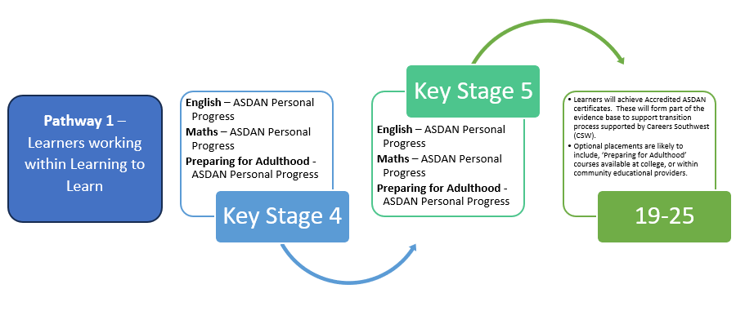  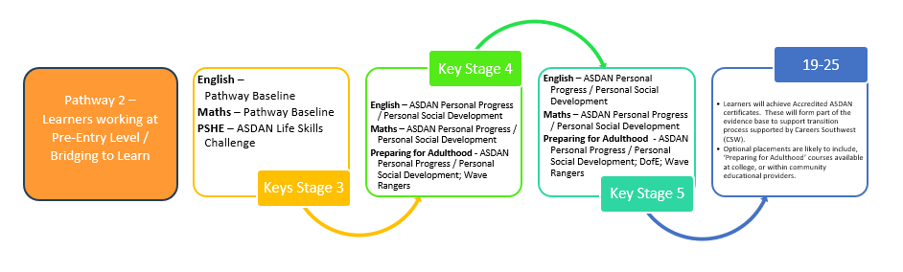  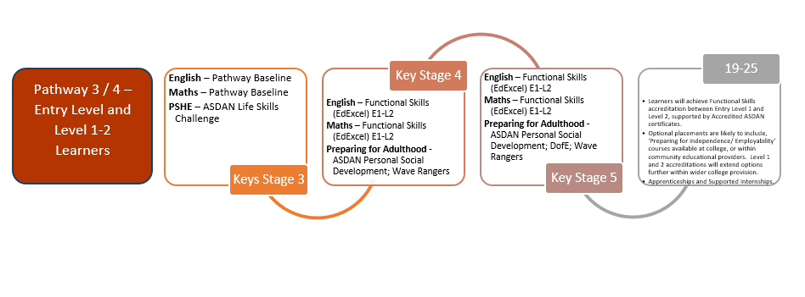
Impact of the Curriculum at Nancealverne School. |  | - The majority of pupils meet or exceed their expected progress. Learners develop detailed knowledge and skills across the curriculum and, as a result, achieve well.  - Detailed analysis of outcomes and pupil progress indicates that there is little statistical significance between the performance of key groups. Where any small differences are identified strategies are implemented swiftly.  - Robust and rigorous data collection and analysis.  - Pupils make significant progression and achieve within personalised Accreditation routes.  - Parents/ Carers views are listened to and acted upon. By building respectful and positive relationships with parents/ carers, the school secures effective partnership working.  - The spiritual, moral, social and cultural development of pupils is paramount and at the heart of the curriculum delivery.  - Pupils are supported to develop outstanding behaviour over their time at Nancealverne, increasing their ability to self-regulate.  - The skilful use of a total communication approach supports pupils’ learning very effectively. Pupils can take a full part in lessons. This results in them making progress and having wider access to the community.  - Pupils are well-prepared for the next stage of their education and the large majority transition to mainstream colleges. No Nancealverne pupil has left Nancealverne not in Education, Employment or Training (NEET) in the last five years.  - Leaders have established a well-structured curriculum to promote work-related learning. This has resulted in pupils having a clear understanding of the different options available when they leave Nancealverne. They are empowered to make informed choices about their future.
How do we know our curriculum is right for our pupils? |  | Top level view:  - Attendance and contribution to Special Partnership Trust wide learning communities. Senior and middle leaders attend.  - Robust and rigorous data collection and analysis.  - Leaders have confident understanding of curriculum intent and sequencing, and how this reflects the vision and values of the school.  - Teachers know and understand why curriculum choices were made.  - Leaders access research and evidence to continually review as needed.  Subject leads:  - Subject monitoring in collaboration with leaders, teachers and pupils.  - Subject leaders have expertise and enthusiasm for continual improvement of subjects.  Bringing it all together:  - The vision and values are reflected in the ‘lived experience of the pupils’.  - Focus on safeguarding, behaviour and attendance all indicate success of the curriculum offer for pupils.  - Destination data and progress outcomes reflect successes.  - Parent and pupil reflections on the curriculum are positive.
Curriculum Access and Engagement Strategy |  | 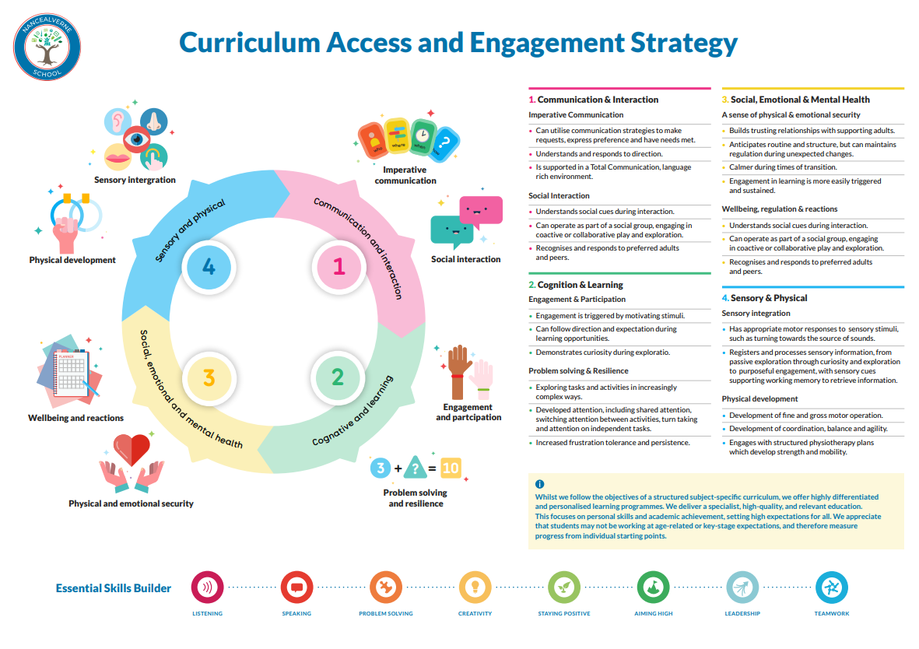  The L2L/ B2L Curriculum Offer will use whatever specialist techniques, teaching approaches, advice & guidance received which will motivate (interest led), support the needs/ improve access of any individual pupils.  The Learning to Learn (L2L) curriculum at Nancealverne School is followed by pupils where a process based, sensory and developmental curriculum is appropriate to meet their learning needs.  These pupils access educational experiences through a Learning to Learn rolling pathway, within which engaging topics are changed half termly. Within this the National Curriculum us used as a ‘vehicle’ for learning securing equality of opportunity in subjects studied / accessed. Within these topics we provide a wide variety of multi-sensory activities, learning invitations and opportunities to consolidate existing skills and to learn new ones.  These learning experiences may be provided in a variety of formats – individual, paired, small group and whole group. However, we recognise the individual needs, personalised learning plans and talents of each learner which facilitates development of their intellectual, moral, physical, social, spiritual and creative capacities. Therefore, each pupil has a personalised learning to learn profile, which includes objectives and targets set taking information from variety of sources including:  - Developmental stage of the learner/ Engagement model of learning  - EHC Plans  - Reports and information from multi-agency teams and involved professionals (including therapy plans and advice/guidance)  - Information gained from parents/carers.  - Levels of support/resources required to access/engage in purposeful learning.  The above is offered by a highly skilled and specialist team of teachers and teaching assistants, working seamlessly with external agencies and multi-professional teams to ensure the best outcomes for our pupils.
Communication |  | 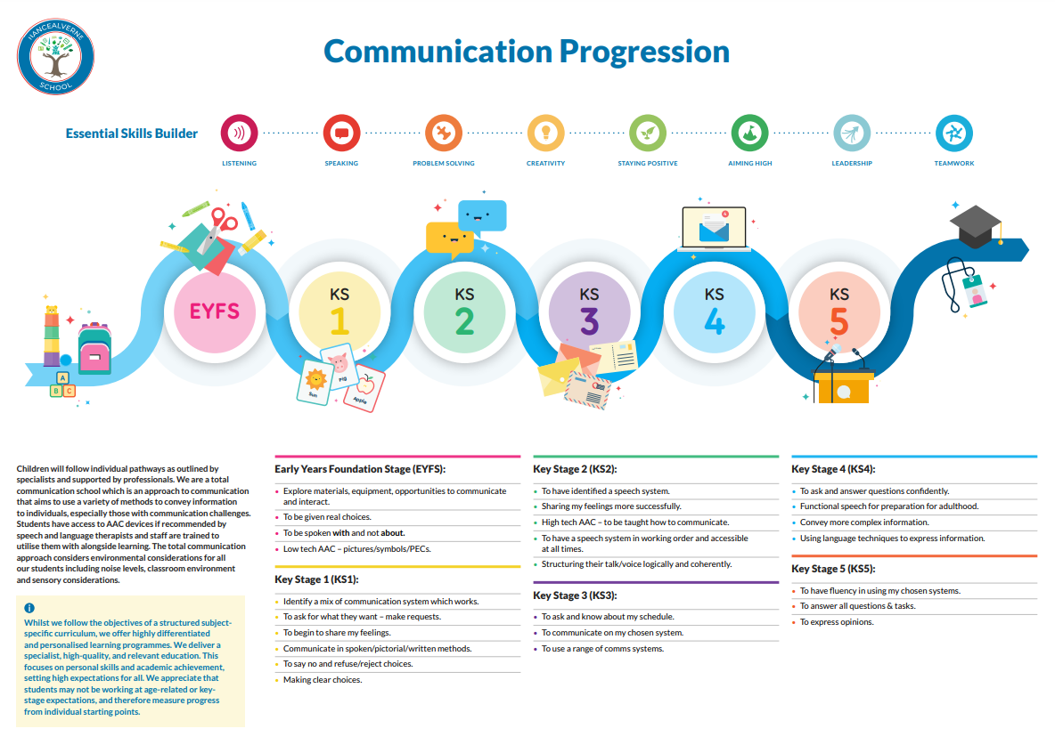
Reading |  | 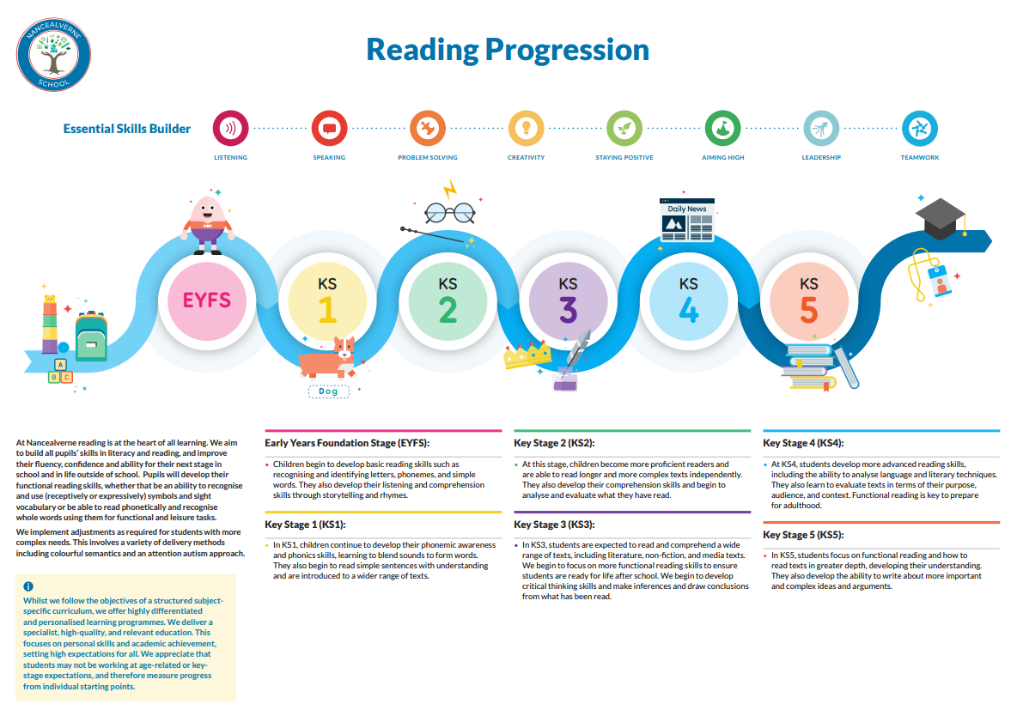
Phonics |  | 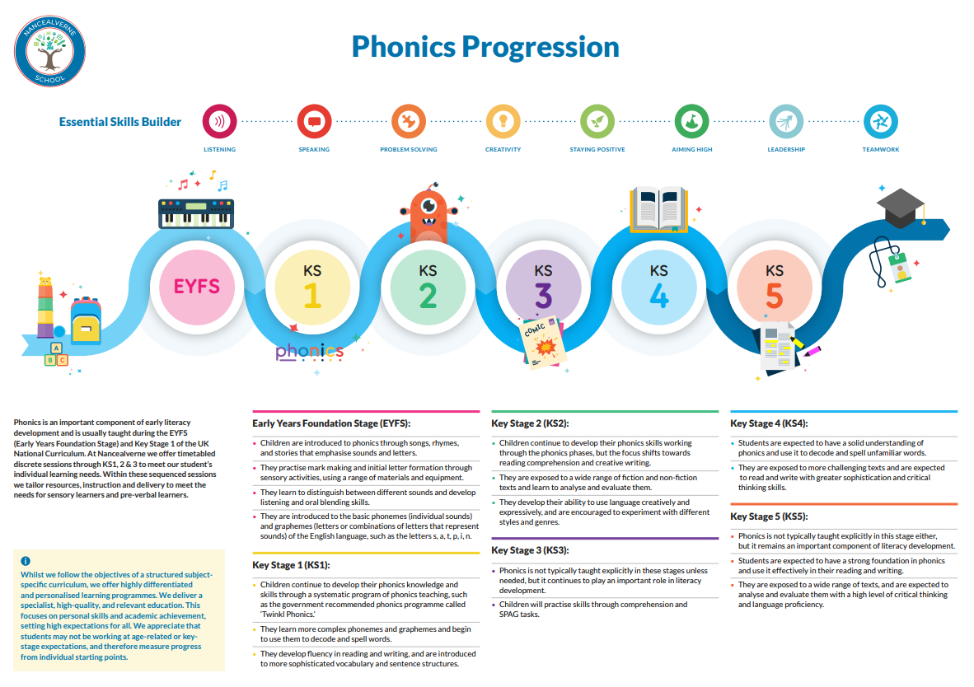
Writing |  | 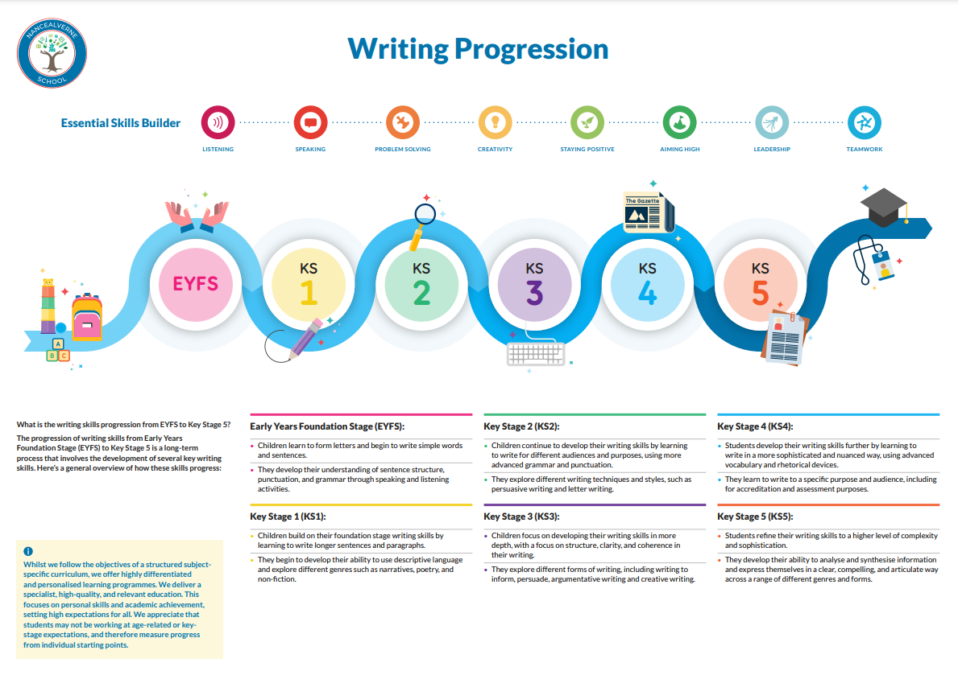
PSHCE |  | 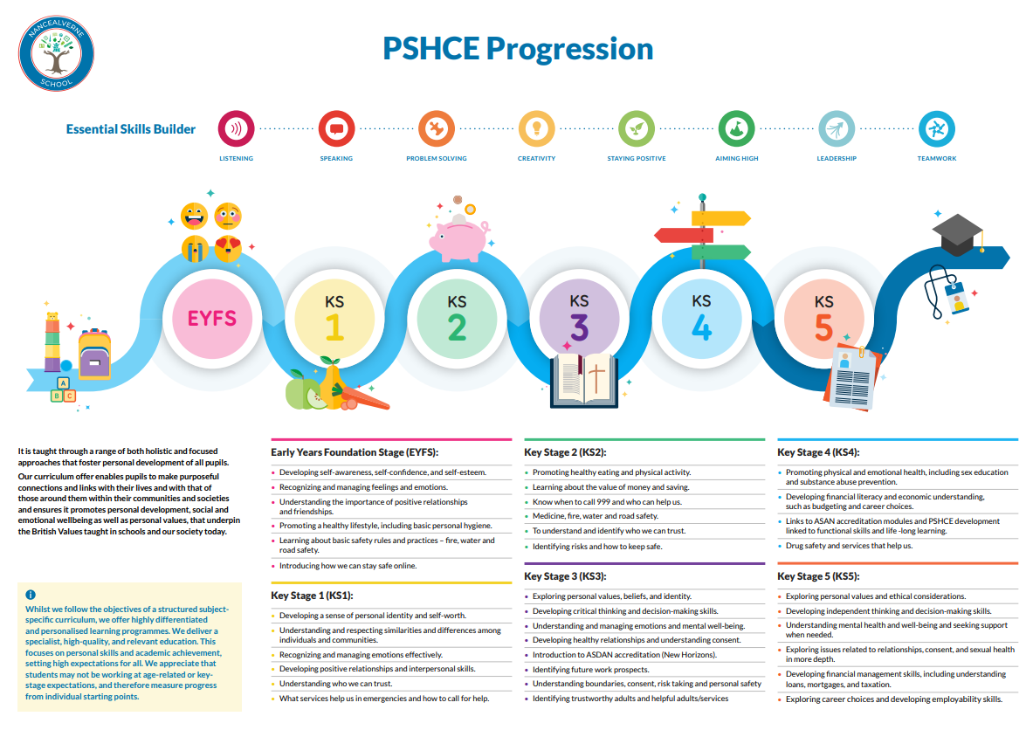
Number and Operations Progression |  | 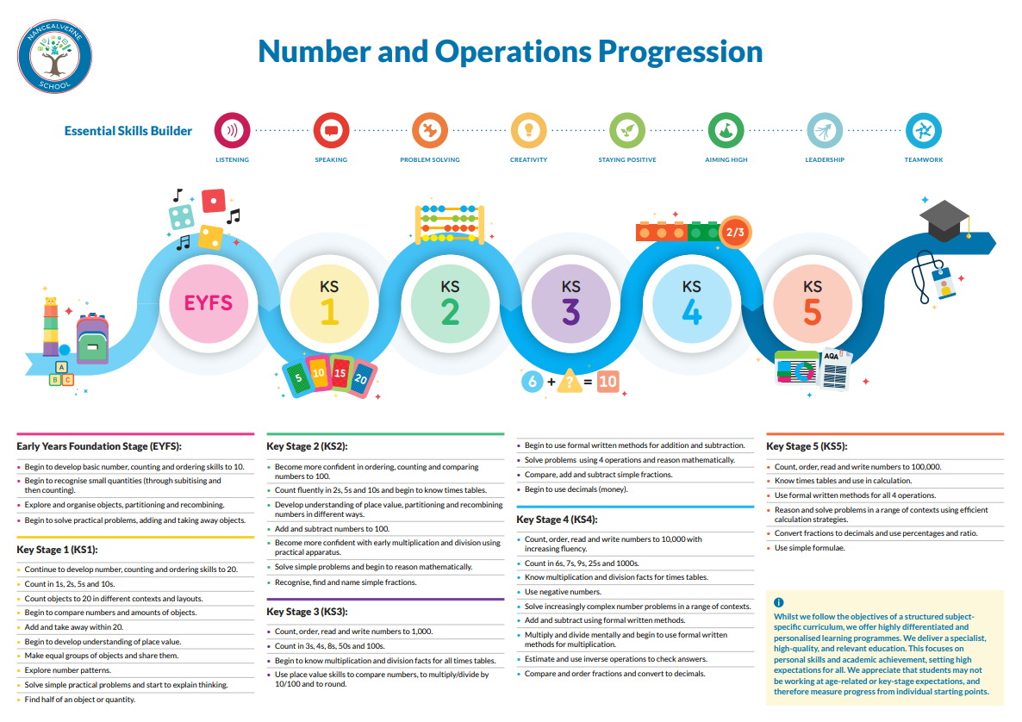
Geometry |  | 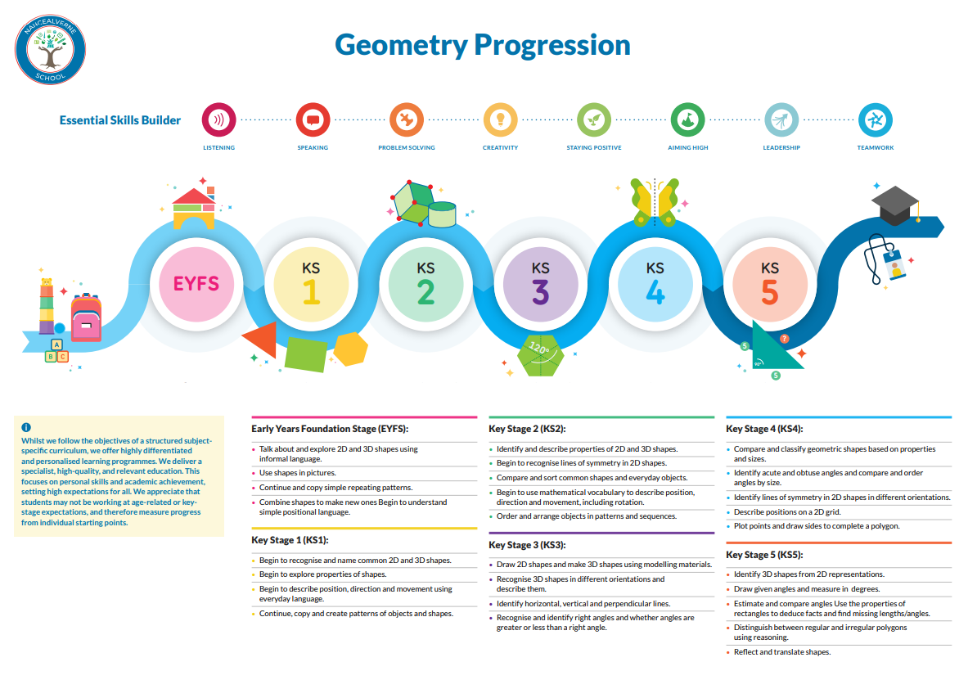
Measuring |  | 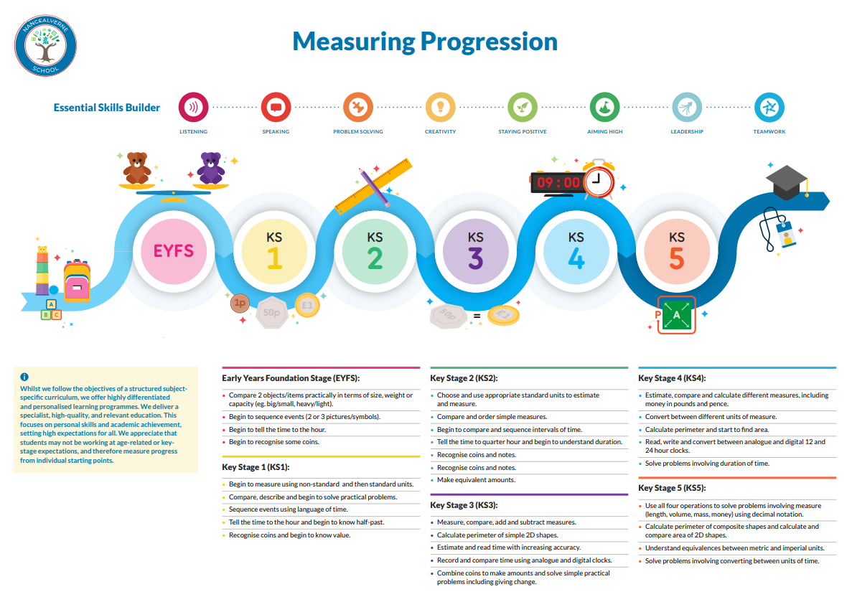
Science |  | 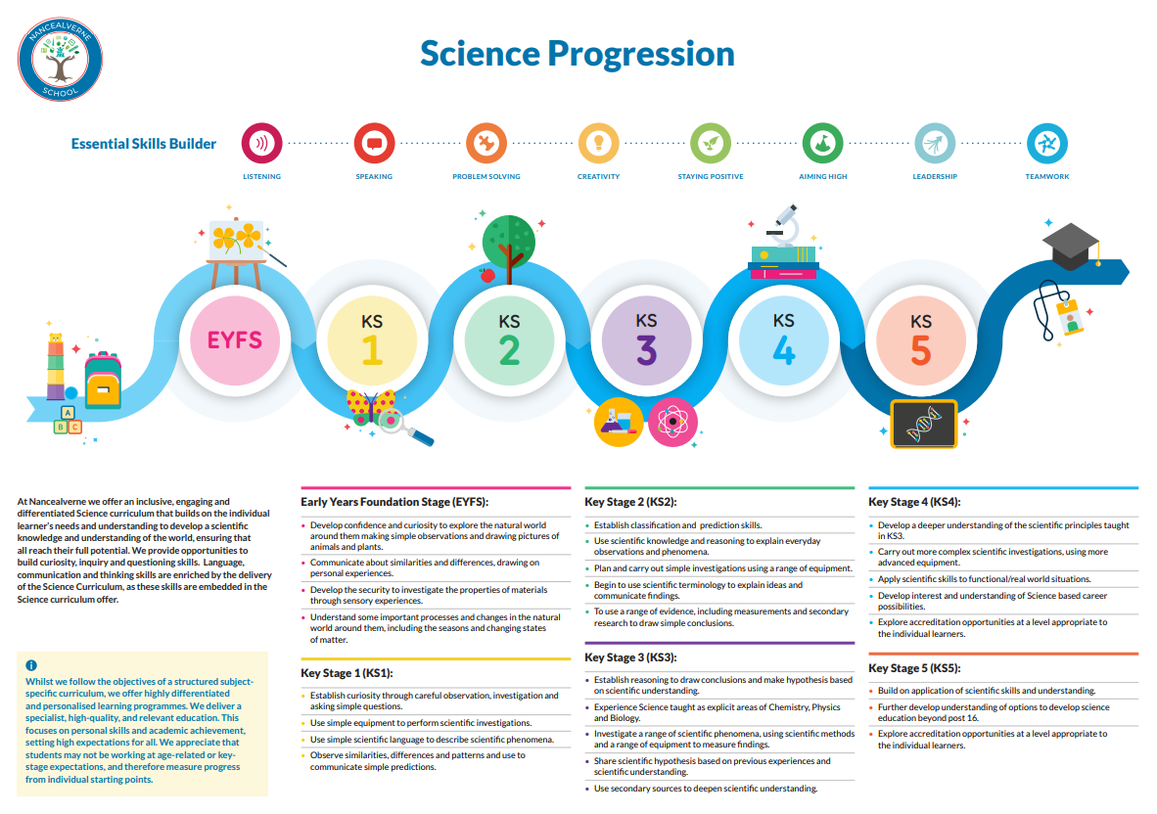
Art |  | 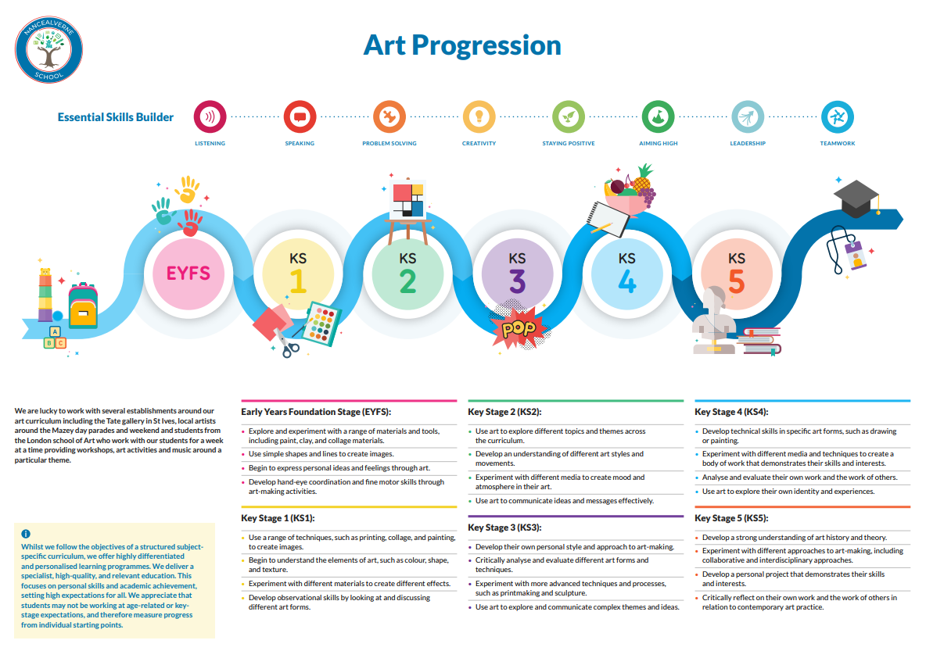
Music |  | 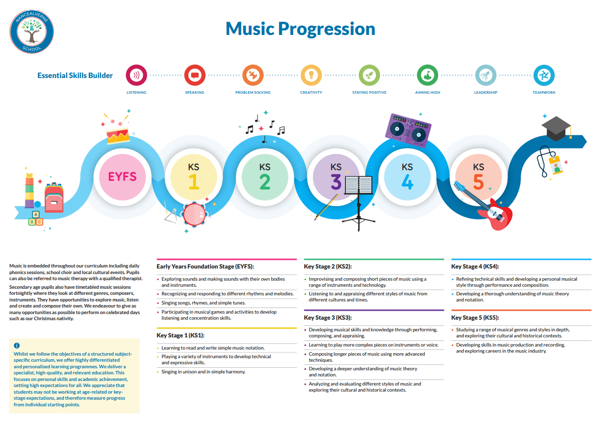
PE |  | 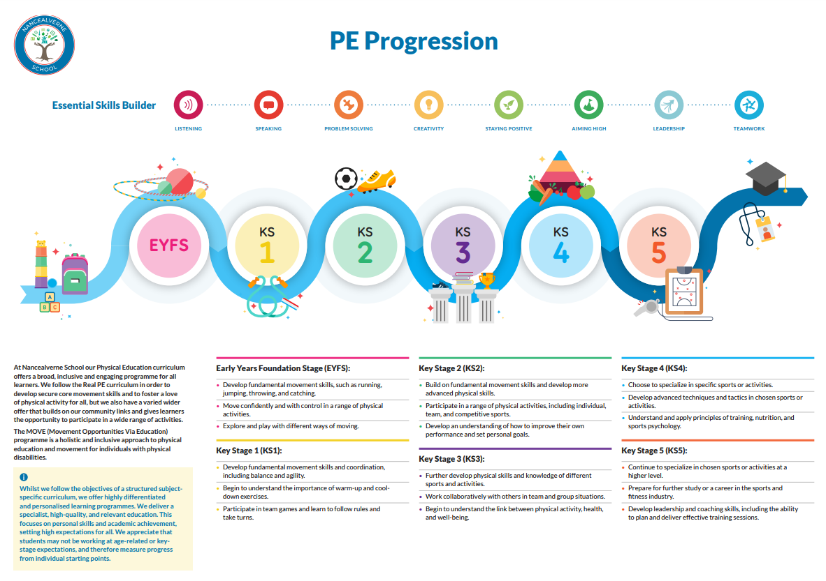
Science
Computing |  | 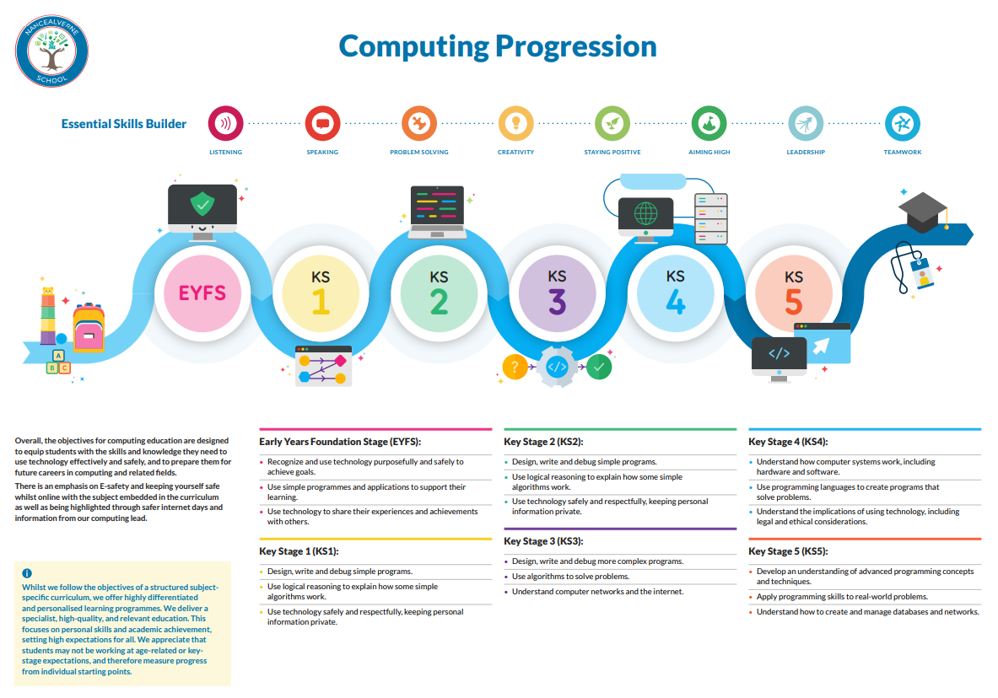
Design and Technology Progression |  | 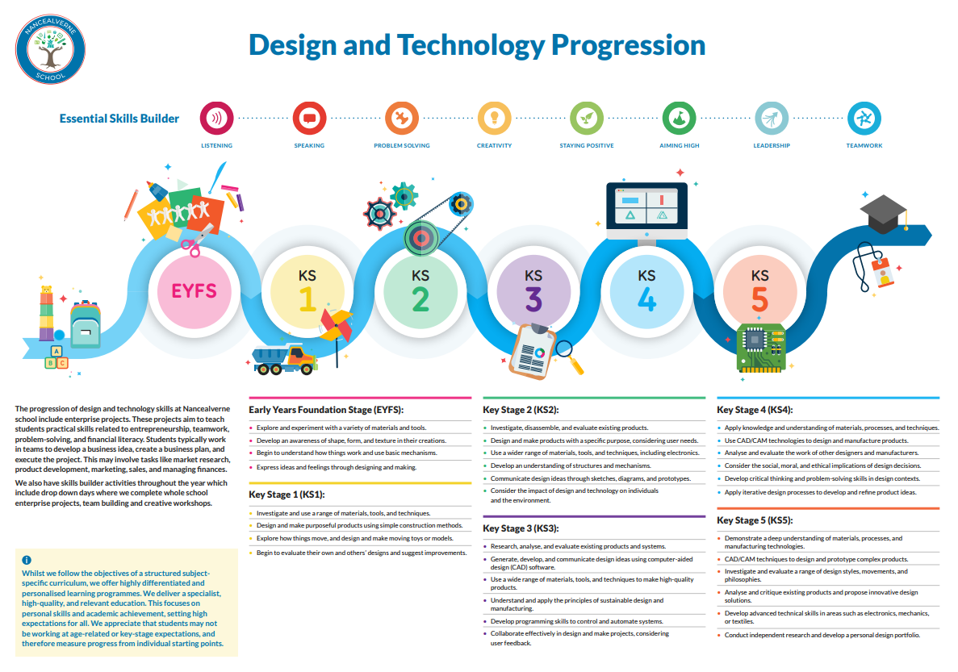
Humanities |  | 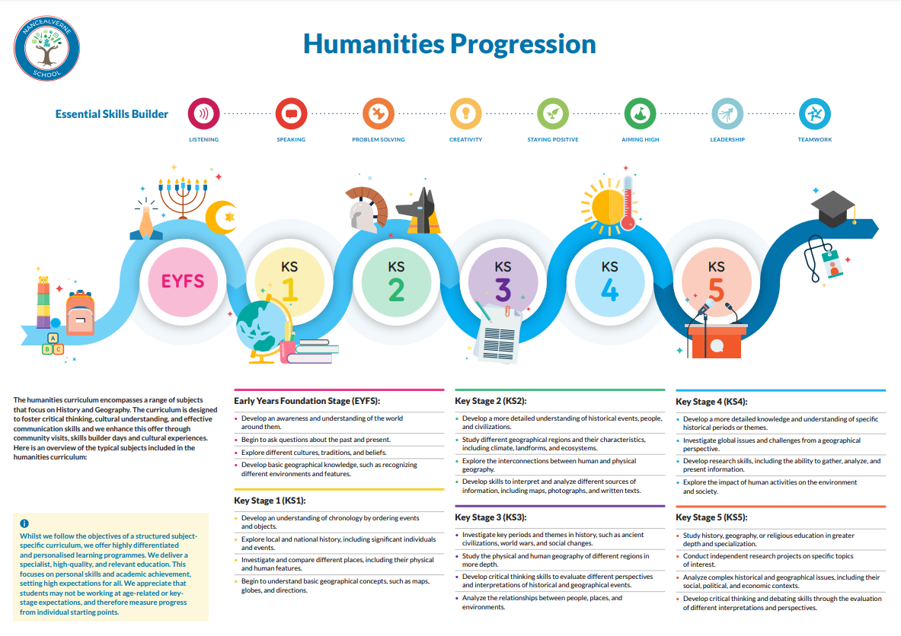
Work Related Learning |  | 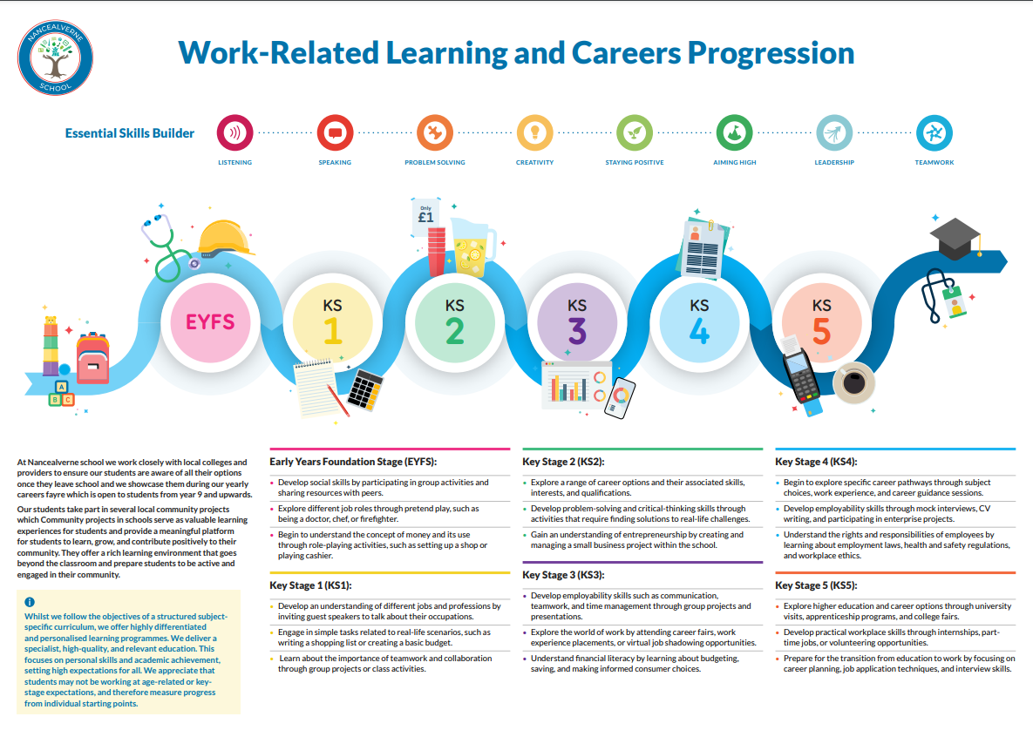
Religious Education. |  | Curriculum progression document to follow. All information available on our website.

